Chess Engines and Opening Recommendations: An Integrated, Data-Driven Approach

Cian Walsh

A Thesis Submitted in Partial Fulfilment

of the requirements for the

Degree of

Master of Science in Data Analytics



September 2023

Supervisor: James Garza

# Acknowledgements

I wish to give thanks to my supervisor James Garza for his guidance and expert knowledge which made this work possible. His insightful questions about my processes prompted me to review every approach I took thoroughly and allowed me to produce this paper to my highest standards.

I would also like to express my thanks to the Faculty of CTT and the Springboard+ organisation. Without these, I would not have had this opportunity to pursue this topic and learn so much in one quick year.

Finally, I must express my greatest thanks and gratitude to my partner Jenny Dempsey. Jenny supported me throughout the entirety of this Master of Science in Data Analytics and provided a foundation for me to apply myself to the best of my ability.

# Abstract

The deceptively complex game of chess has interested many people for centuries, from casual players to historically impactful mathematicians. With permutations of a chess board exponentially increasing with every move, data analytics and machine learning have become indispensable in their ability to refine the possible outcomes of a game. In this research, experiments on the effect of the search horizon will be performed on two world-class chess engines to reveal the search pattern most suitable for early game analysis.

Following this, the exploration of players and their relationships with the opening moves of a chess game inform the development of a recommendation system. The system will culminate in historical chess data combined with a new approach to implementing chess engines as data analytics tools to provide players with an informed method of expanding their opening repertoire.

ii. Table of Contents

Acknowledgements 2

Abstract 3

iii Table of Figures 5

iv. Table of Tables 6

Chapter 1: Introduction 6

Chapter 2: Research Design 8

2.1 Primary Data 8

2.2 Problem Identification and Clarification 8

2.3 Research Objectives 9

2.3.1 Chess Engines and the Horizon Effect 9

2.3.2 Player Rating and Opening Move Distributions 10

2.3.3 Chess Engine Evaluation and Real-World Outcomes 10

2.3.4 Recommendation system 11

2.4 Ethical Considerations 11

Chapter 3: Literature Review 12

3.1 Introduction 12

3.2 Discussion 12

3.2.1 Why Chess? 12

3.2.2 Game Theory 13

3.2.3 Rating Systems 14

3.2.4 Chess Engines 15

3.2.5 Search Algorithms 15

3.2.6 Stockfish 16

3.2.7 Leela Chess Zero 17

3.2.8 Open Source 17

3.2.9 Reinforcement Learning 17

3.2.10 Neural Networks 18

3.2.11 Classification Models 19

3.2.12 Chess Openings 20

3.2.13 Choice 21

3.2.14 Recommendation Systems 21

3.3 Conclusion 22

Chapter 4: Methodology 24

4.1 Data Collection and Pre-Processing 24

4.2 Puzzle Analysis 25

4.3 Player Opening Distribution Analysis 27

4.4 Opening Analysis 29

4.5 Recommendation System 30

Chapter 6: Results 34

6.1 Puzzle Analysis 34

6.2 Player Opening Distribution Analysis 37

6.2.1 Diversity Distribution 37

6.2.3 Distinction in Opening Repertoire 40

6.3 Engine Analysis of Openings. 41

6.4 Recommendation System 43

Chapter 7: Discussion 46

7.1 Puzzle Analysis 46

7.2 Player Opening Distributions 47

7.3 Opening Engine Analysis 47

7.4 Recommendation System 48

Chapter 8: Conclusion 50

References 52

Appendix A: Workflow 58

Appendix B: Data Permissions and software Licenses 58

Lichess 58

Stockfish 58

Leela Chess Zero 58

Python 59

# iii Table of Figures

Figure 1 - Time Comparison of Stockfish and Leela Chess Zero 36

Figure 2 - Seldepth Comparison of Stockfish and Leela Chess ZERO 36

Figure 3 - Nodes Comparison of Stockfish and Leela Chess ZERO 37

Figure 4 - K Value Assessment for Diversity Clustering 38

Figure 5 - Shannon Diversity Clusters 38

Figure 6 - Gini Diversity Clusters 39

Figure 7 - Diversity Clusters by Rating 40

Figure 8 - K Value Assessment for Opening Choice Clustering 40

Figure 9 - Opening Choice Clusters by Rating 41

Figure 10 - Correlation Heatmap of Engine Evaluations 42

Figure 11 - Results of Regression Analysis on Engine Evaluations 43

Figure 12 - Jaccard Similarity of Recommendations 44

Figure 13 - Sequence Similarity of Recommendations 45

# iv. Table of Tables

Table 1 - Description of Behavioural Moves 31

Table 2 - Result of Engines Solving Mate in X Problems 34

Table 3 - Result of Shapiro-Wilk test for Stockfish and Leela Chess Zero Evaluation time 34

Table 4 - Result of Whitney-Mann U test for Parameter Comparison 34

# Chapter 1: Introduction

Chess, a game devised of set pieces and simple rules, appears as though it can be played with quick thinking and decisive strategy alone. When played however, it is quickly revealed that the permutations of the 16 pieces on the 64 squares has an innate complexity that interested mathematicians for centuries (Hernández, 2023). The intricacy of chess has been long investigated, with many attempts at determining the possible combinations of pieces on a board estimated to reaching a lower bound of 10120 as determined by Shannon, an early pioneer of modern chess engines (Shannon, 1950).

When considering permutations of a chess board, each game starts with an opening sequence of moves. After 5 moves, there are 4,897,256 total possible board positions, and after 7, there are 3,284,295,545 (Edwards, 2003). With so many possibilities, the end of an opening sequence has huge potential to influence the outcome of a game, both positively and negatively.

Modern methods to address the complexity of chess and provide attempts to determine the “solution” of the game come in the form of machine-learning-based chess engines. These engines are designed based on the fundamentals of data analytics and statistics. The end goal of engines is to refine the mass volume of data considered in a chess position to a point that is easily interpreted by a player. Most modern engines use heuristics designed by human input into the search and evaluation functions, the most prominent example today being Stockfish (Stockfish, n.d.). Alternative procedures for developing engines using more advanced techniques are becoming frequent, with Leela Chess Zero being considered one of the top current engines (Authors, 2023). Leela Chess Zero and its predecessor AlphaZero from Alphabet’s Deep Mind are designed through the implementation of neural networks (McGrath, 2022), an artificial intelligence method that is in the forefront of current data analytics processes.

When considering the information refinement potential of these engines and the complexity that comes from only 7 initial moves in a chess game, the incorporation of these machine learning based algorithms as a data analytics tool has real world benefits.

Through a detailed application of data analytics and machine learning, the research carried out in this report will investigate the procedure for processing chess databases; conducting experiments on world class chess engines; and exploring relationships between chess players and their choice of openings. The culmination of these processes will come in the form of recommendation systems based on combinations of ranking metrics, player behaviour, and player opening dynamics. This will demonstrate the practical application of chess engines as data analytics tools to provide players with a series of recommendations to expand their repertoire.

# Chapter 2: Research Design

The following section will detail the process of identifying the research subject for this report and describe the specific objectives derived to address the research problem. The research objectives are broken down by the tasks required to handle the problem and the gain they will provide regarding the research. Alongside this, identifying a source of primary data is detailed, which describes both the method of sourcing through experimentation and the specific use case for the data once established.

## 2.1 Primary Data

Primary data for the problem set identified in this research will be established through an experimental process of the application of two of the top chess engines, Stockfish and Leela Chess Zero to a collection of defined solution *Mate in X* puzzles. By running the engines on these puzzles, parameters for time of search and depth of search will be collected and statistically compared to evaluate any possible power gain in selecting one engine over another. Furthermore, the engine with higher established capabilities concerning the horizon effect will be incorporated into designing a recommendation system. The effects of this will be seen by developing a new criterion for ranking openings by value gain rather than win rate. With this new metric established, a comparative analysis will determine the feasibility of using engine-derived information for practical use outside a game-specific analysis scenario.

## 2.2 Problem Identification and Clarification

Chess, a game that requires players to employ both their knowledge of tactics and to derive their assessment of positions, involves the implementation of the analysis of data throughout every game. Initially, chess games, like many problem sets, required a thought-driven analysis on a human level. However, chess analytics and many other fields have changed significantly with the implementation of machine learning and the development of chess engines.

Since the inception of chess algorithms in the 1940s by Claude E. Shannon (Shannon, 1950) and Alan Turing (Turing, 1953), they have changed the approach to the game with interest from both players and mathematicians. Algorithms devised for chess engines come in many formats, such as human-designed, Alpha-Beta-Pruning-based engines like Stockfish (Stockfish, n.d.) and Neural Network designed, Monte-Carlo Tree search engines like Leela Chess Zero (LeelaChessZero, 2023). This diversity in engine design offers different approaches to assessing a chess position. It creates natural competition to find the most potent position evaluation methodologies, which can be seen in the Top Chess Engine Championship, with both Stockfish and Leela Chess Zero having won the title of champion within the last decade (Wiki, 2023).

With chess engines being available to players for post-game and specific position analysis, this project aims to expand the use-case of the data analytics tools known as chess engines to provide players with recommendations of openings to aid in expanding their repertoire. Using a chess engine to study openings and the progression of games played with those openings, an alternative evaluation metric could provide a better ranking basis for openings compared to the overall player success rate.

The process of determining the feasibility of this must consider the following objectives: choosing the engine which is most capable of assessing a position given limited computational ability; understanding the potential difference in the analysis of openings when compared to real-world outcomes; the uncovering of possible opening selection dynamics based on the scaled rating of players within chess datasets; and the evaluation and justification of recommendation differences identified by establishing alternative valuation metrics.

## 2.3 Research Objectives

### 2.3.1 Chess Engines and the Horizon Effect

Chess engines incorporate different algorithms for determining the optimal line of play in a given position. Stockfish incorporates an Alpha-Beta Pruning search algorithm that uses human-trained heuristics and weightings to determine the value of search paths and the cutoff points for the pruning of its search nodes. Leela Chess Zero, a relatively new competitor in the chess engine space, uses an alternative search method known as the Monte-Carlo Tree search, which randomly iterates through more linear search nodes to reach an optimal solution. Unlike Stockfish, Leela Chess Zero is trained through a neural network. A series of games are played an analysed by the neural network, allowing Leela Chess Zero to develop its own heuristics and weights for the searching of branch nodes.

The horizon effect is an obstacle for all search algorithms where a solution to a problem lies beyond the depth restriction of a search algorithm, such as the depth limit option in Universal Chess Interface compatible engines like Stockfish and Leela Chess Zero.

The objective identified, is to comparatively examine any measurable differences in the parameters required by engines for solving hidden search patterns through the evaluation of *Mate in X* puzzles.

### 2.3.2 Player Rating and Opening Move Distributions

With a large variety of standardised chess openings available to everyone who plays a game of chess, players can be as selective as they wish regarding how they approach the initial stage of a game. Considering behaviours expected at different skill levels, a reasonable assumption would be that highly skilled players would be somewhat selective of their openings and maintain a lower diversity in their selection. Using ecological diversity metrics, statistical methods, and machine learning applied to real-world data, this section aims to establish the possible rating divisions within the chess player population at which selection approaches of openings differ.

Furthermore, this exploration will provide insight into the pool of openings selected by players. By establishing a possible pattern between a player at a particular skill level and the openings they choose from, information may be further incorporated into new areas of research, such as the development of a recommendation system to help inform players of openings that would be suitable for their play style or historical use.

### 2.3.3 Chess Engine Evaluation and Real-World Outcomes

Chess openings are defined by a classification based on codes from the Encyclopaedia of Chess Openings (ECO), (Matanovic, 1978), which can be further subdivided into sections: *Opening*, *Line*, and *Variation*. The Opening is the initial one to two moves played, the Line is the approach taken after these moves, and the Variation is a slight difference to change the overall tactical approach of the opening.

A famous example is the “Queen’s Gambit”; its lines and variations are classified under the umbrella of code D06, and its variations are under codes D07-D69. Each opening has a series of pros and cons depending on the player's desired approach to the game. This approach to a game can be defined by several factors including time control, play style, and knowledge of the opponent and their repertoire. However, this is more so the case in classical over-the-board games.

Each opening has varying success rates with different players. This is because the opponent can alter the game significantly with every possible move after an introduction is played, increasing the number of permutations a chess board can take. Given a chess engine’s ability to search both broader and deeper than a human, the purpose of this analysis is to derive insight into the possible benefits of a chess engine evaluation can be considered concerning the real-world outcome of chess games.

### 2.3.4 Recommendation system

The final objective of this research project will leverage the insights gained in the previous objectives by introducing a recommendation system as a real-world application of analytics that can be derived from historical chess data and chess engines. Combining the analysis gained from the exploration of chess engines and their evaluation of games based on their opening with the understanding of player-opening relationships, the impact of metrics and groupings on a recommendation system can be derived and interpreted.

This integrated objective will serve as a demonstration of the synergistic nature of the objectives in this project and as a suitable application of the primary data obtained in the evaluation of chess engines.

## 2.4 Ethical Considerations

Due to the nature of this project relying on open-sourced and free-to-use chess engines in combination with open-licensed data, there are no ethical considerations concerning fair usage. Both Stockfish and Leela use a GPLv3 license, meaning general use is under no restrictions. Though, any adjustments to source code must be documented, the original source must be packaged with the adjusted program; and attribution is also necessary. Data from Lichess' database is under Creative Commons 0 (CC0), which allows for complete access and usage without any attribution, but their website notes that it is appreciated. The company also supports and encourages the use of data from Lichess.

Ethics regarding personal data are not of concern due to no personal identifying data collected in the PGN format from chess games except for usernames which belong to Lichess, and which they are free to distribute.

Results from this project are obtained from using open-sourced engines on free access data. From this, no results will be restricted and therefore there are no concerns for publishing the results from an ethics perspective.

Consideration must be given to establishing power gain from a chess engine when provided with a specific subset of puzzles for testing. It is to be understood that this report does not imply an objective superiority of one engine over another for all uses. Results from chess engine-specific comparative sources such as Top Chess Engine Champion (Wiki, 2023), which hosts competitions for engine developers to submit their engines for tournament and league head-to-head comparisons, provides a resource for a more generalised assessment of chess engines.

# Chapter 3: Literature Review

## 3.1 Introduction

Chess is a game with a historical foundation that has developed into a canvas for many mathematics and human psychology research areas.

Chess fascinated some of the mathematical pioneers of what became computer science. From here, this literature review explores the concepts behind analysing chess, attempts to solve the highly complex system of the 32 pieces on a 64 square board, and the algorithms defining the research into chess.

The study of chess is no trivial task, with complex mathematical concepts being employed, such as neural networks and high-powered computation required. Open-source software development has led to the release of the current highest-strength chess engines. With so much research, collective development, and routes to explore within chess. I believe there is scope to explore the topic and use the blank canvas chess presents to explore how different engine algorithms work and use their outputs to assist chess players in choosing opening move sequences that suit their needs.

## 3.2 Discussion

### 3.2.1 Why Chess?

The precursor to chess, known as "chatrang", can be traced back to the 5th Century AD in North-West ancient India. From this origin, chess spread globally with many variants to become the modern format we know today, with pawns, knights, bishops, rooks, a queen, and a king. (Alvi, et al., 1990)

From the point of origin, chess has fascinated many, including some of the pioneers of programming, one being Claude E. Shannon. Shannon wrote a paper for chess programming in 1949, long before high-power modern computers with silicon transistors were even a concept. Shannon's early design involved simple rules and was deterministic in its approach; he also notes a weakness in analytical ability and recognition in basic computational chess. (Shannon, 1950)

Like Shannon, Alan Turing, the famous mathematician whose work significantly impacted the outcome of World War 2, viewed chess as a way to test the emergence of programmatic algorithms. Like Shannon, Turing developed a chess-playing algorithm that required written computations to determine a move. His works were published in an article in 1953, “Digital Computers Applied to Games.” (Turing, 1953)

Other games have also been of interest for programming, including another old game Backgammon. In 1995, Gerald Tesauro published a paper detailing the use of reinforcement learning algorithms to develop a self-learning neural network (Tesauro, 1995). This method of providing a blank slate and allowing a neural network to learn by doing is still seen today in modern chess engines such as Leela Chess Zero (Wiki, 2021).

This concept of applying reinforcement learning to complex games was seen in the development of AlphaGo by DeepMind (Silver, et al., 2017). AlphaGo was a conceptual experiment to develop a self-learning game engine, later adapted into a generalised engine known as AlphaZero, which also worked for Chess and Shogi. Before the release of the previous paper, Diwas Sharma and Udit Kr. Chakraborty discussed the concept of applying neural networks to a complex game such as chess (Sharma & Chakraborty, 2017). They note the possibility of developing a fully-fledged chess-playing machine that has been self-taught without human intervention, a concept that had not been observed but is now commonplace, with Leela Chess Zero being freely available and open source.

While there have been great advances in the use of machine learning in chess, complications have arisen in the form of foul play. Delia Monica Duca Iliescu discusses the increased need for cheat detection software, particularly the delicate balance required in identifying and misidentifying cheating (Iliescu, 2020). They also note that despite machine learning being a source of the problem, machine learning, specifically artificial intelligence, may a be the solution.

The combination of early history, pioneer programming methods, modern experimentation, and problem-solving make chess an exciting prospect for studying and developing new and exciting demonstrations of data and the information data analytics can extract.

### 3.2.2 Game Theory

According to Peter Morris chess is a game that follows the mathematical concepts of “game theory”, this means the game has a finite set of players, a finite set of moves to play, a limit to possible game length, and all players have access to the same set of moves, and there is a numerical payoff in the event of a victory (Morris, 2012). This is reflected also in Martin Osborne’s, An Introduction to Game Theory, where he comments that there is no empirical evidence of advantage for one side in a game of chess, unlike other games such as tic-tac-toe which have been “solved.” (Osborne, 2209)

Anatol Rapoport comments on this further, with the statement “That is to say, Chess is a game with a saddle point, and this implies the existence of an optimal pure strategy available to each player.” (Rapoport, 2013) This point is crucial to the foundation of why chess is found in many machine learning research papers. It presents a highly complex system, wherein the number of moves is beyond any calculation ability, but the game rules set imply that it should technically be solvable.

Given a game with a finite number of players, John F. Nash posits that there exists an equilibrium point, where two players playing a perfect set of moves will repeat the outcome each time (Nash, 1950). This concept is known as the Nash equilibrium and is what Rapoport is referring to with his description of a saddle point.

Although there is the discussed possibility of an equilibrium of optimal play being achievable in chess, a journal article regarding the complexity of determining the equilibrium by computation questions whether the Nash equilibrium is sufficient as a general-purpose framework for behaviour prediction (Daskalakis, et al., 2009).

Despite this, a study based on top-level chess players found that many of the players exhibited the ability to induct games where possible backwards (Levitt, et al., 2011). While this does not cover all cases, chess as an entirety, it does show possible links between chess and an equilibrium point of existence.

### 3.2.3 Rating Systems

The fundamental idea behind rating systems used in chess is the Elo rating system. It is based on the expected result of a game based on rating differences and factors that, with the actual result, adjust both players' ratings accordingly. Glickman also discusses in his guide to rating systems the variability in these systems and the need to update them and question their validity and suitability (Glickman, 1995).

From this need for questioning and updating, Glickman went on to develop the Glicko rating system. This rating system is put forward to reflect variances more reliably in ratings outside of just the number given, namely the “rating deviation” (Glickman, 1995).

The Glicko System has since developed into Glicko-2 and is the current rating method implemented by Lichess and the Australian Chess Federation. It is considered more accurate than its predecessor by controlling for expected deviation (Chowdhary, et al., 2023).

A statistical analysis of the Elo rating system quantified the observed prediction error calculated using Elo. It found that on the higher end of Elo ratings, a significant difference in rating resulted in a higher prediction accuracy error, such that if a player rated 2,400 and a player rated 2,872 (Magnus Carlsen’s rating at the time of calculation), the prediction error would 0.09 (Berg, 2020)

Chess rating systems can also be used to develop novel rating systems for evolutionary algorithms as discussed in a 2016 paper by Veček et al. The paper discussed an adapted version of the popular Glicko-2 system as a suitable option for performance comparison in non-chess-related situations, such as evolutionary algorithms (Veček, et al., 2016).

### 3.2.4 Chess Engines

Chess engines are data analytics programs that are designed to take a given position in a chess game and return an evaluation for the best move given its own valuation algorithm and search parameters.

Chess programs have been studied and discussed since their conception from the likes of Shannon and Turing. The book “Computer Chess Compendium” discusses their papers in detail and provides valuable context on many chess programs developed before its publication in 1988. The tree search, an algorithm that is still in use in modern chess engines is detailed and notable examples and accounts of its implementation are demonstrated (Levy, 1988)

From these famous examples of chess programs evolved new techniques and what became the modern chess engine. In 1997, Deep Blue played World Chess Champion Garry Kasparov, resulting in a historic first win for a chess engine against a top-level chess player. Feng-Hsiung Hsu’s book “Behind Deep Blue” details the story from the beginnings to the moment of victory for Deep Blue and notes just how significant of an achievement this victory was. (Hsu, 2002)

Chess engines require search algorithms to work through the trees of data created by exploring possible move sets. One way of handling these trees is to implement the alpha-beta pruning algorithm. This minimax algorithm does not explore branches of a tree that would not be likely to result in the optimal solution (Knuth & Moore, 1975). Knuth and Moore note this algorithm has possibility for chess application, which we see in modern chess engines like Stockfish (Wiki, 2022).

### 3.2.5 Search Algorithms

The alpha-beta pruning algorithm refined in 1975 by Donald Knuth and Ronald W. Moore (Knuth & Moore, 1975) after its conception in 1963 by Alexander Brudno (Brudno, 1963) is a crucial feature of how the chess engine Stockfish works. According to its creators, the model in its raw, unoptimised format can be rather pessimistic. They do not despite this they considered it to be reasonably efficient.

In Stockfish, the minimax algorithm is used with alpha-beta pruning, it is arguable as to which is more efficient, and this is discussed by Plaat et al. They note that the minimax algorithm they analyse is more efficient in search but at the expense of memory capacity (Plaat, et al., 1979). This may have been a concern in the past but with modern computers and high memory availability, perhaps the expense is not too great.

Considering the possibility of a minimax algorithm having greater application in tree search, an experiment to determine its efficiency with parallel computing was completed by Borovska & Lazarova. It was found that there was a notable performance increase based on hybrid parallel programming (Borovska & Lazarova, 2007). This parallel processing computing is seen in modern chess engines (Guidry & McClendon, 2009).

The Monte Carlo tree search is an algorithm employed by many game engines, including Leela Chess Zero. It has seen success in many applications recently, with a 2017 article describing the algorithm's usability to stem from its ability to preserve rank ordering states despite the random element of its search methods (James, et al., 2017).

With the general superiority of alpha-beta searches in games, many researchers are trying to develop new methods that implement the Monte-Carlo tree search to gain more output performance from the search algorithms. One example is progressive strategy, a conceptual performance enhancer that may potentially provide a benefit in search strategies within games (Chaslot, et al., 2008).

Regarding chess as a use-case for search algorithms, an alternative approach was researched by Hauptman and Sipper who they developed efficient methods through genetic programming. It was found that they could achieve a 47% reduction in searched nodes over CRAFTY, a high-powered chess engine, but they still could not outperform the alpha-beta pruning search algorithm (Hauptman & Sipper, 2007).

### 3.2.6 Stockfish

Stockfish is an open-source, free-to-use chess engine first released in November 2008. Stockfish is an example of a chess engine that uses alpha-beta pruning in its search trees, which use a minimax algorithm. This combined search method produces a powerful static evaluation function (Hamzah, 2022).

Stockfish is designed to work with the Universal Chess Interface and is licensed under GPL 3.0 (developers, n.d.). Stockfish is an example of an engine that employs alpha-beta pruning in its search algorithm; it also heavily relies on heuristics and reduction techniques to optimise searching (Maharaj, et al., 2022).

It is currently considered the best chess engine in the world, having been declared the champion of the Top Chess Engine Championship from season 18 up to the 24th season, which concluded in April 2023. Leela Chess Zero was runner-up in 6 of the seven victories for Stockfish and was the top chess engine champion in seasons 15 and 17 (Wiki, 2023).

### 3.2.7 Leela Chess Zero

Leela Chess Zero is also an open-source, free-to-use chess engine. Leela Chess Zero, a recreated version of AlphaZero from DeepMind, incorporating the same two-headed architecture seen in its predecessor (Haque, et al., 2021) was conceived and developed much later than Stockfish.

Leela Chess Zero is a continuously developing project and is an example of a promising new tool for chess analytics that incorporates modern, new mathematical approaches (Authors, 2023).

### 3.2.8 Open Source

In his article “The Open Source Definition”, author Bruce Perens highlights the fundamental attributes and benefits of the open source system. He notes the scaling of open-source products and the success of the Linux Operating System (Perens & others, 1999). Many examples of chess software are open source, such as Stockfish, Leela Chess Zero and Lichess.

Understanding open source software development is a book discussing the reasons for using open-source software. In this book, it’s discussed that the methodology of development promoted a relationship between the companies developing and the community of users. It was found to be supportive of product additions and maintenance (Feller & Fitzgerald, 2002)

Open-source software has seen significant growth in the past, according to a paper on the economics of open-source software. This paper discusses the difficulties arising from the permitted “forking” of open-source software (Lerner & Tirole, 2002). In reflection, “forking” has been a positive for the chess software world, with Stockfish initially being a fork of another chess engine, Glaurung (Wiki, 2021).

Concerns regarding the motivations behind the open source software movement were considered by Grodzinsky et al., where without an obvious financial incentive, it is not always clear what the intentions behind developers are. Despite this, they note, there is no overwhelming evidence of detrimental quality for nefarious reasons (Grodzinsky, et al., 2003).

### 3.2.9 Reinforcement Learning

The University of York defines reinforcement learning as “a subset of machine learning that allows an AI-driven system (sometimes referred to as an agent) to learn through trial and error using feedback from its actions.” (University of York, n.d.) This machine learning method allows for a relatively hands-off development of models that can solve problems through an iterative learning process.

Reinforcement learning is gaining popularity in modern technology, such as the Internet of Things, energy management, security, and recommendation systems (Sivamayil, et al., 2023). It has a history with top mathematicians such as Claude Shannon, who demonstrated the concept using a maze-running mouse in 1952 (Sutton & Barto, 2018).

MarsExplorer is an example of a reinforcement learning environment where the learning will have real-world transferability (Koutras, et al., 2021). It is a new openai-gym environment and serves as a testing ground for reinforcement learning to be tested for robotics to handle the problem of exploration of a completely foreign area.

Reinforcement learning has also been used to develop models for use in autonomous driving software. Autonomous driving presents a particular challenge for this form of machine learning with many varying obstacles, from vehicle-to-vehicle communication to road conditions and mapping accuracy issues (Yurtsever, et al., 2019). Frameworks to handle these difficulties are still continuously in development, as noted in a 2022 paper, which presents an autonomous driving solution through a combination of RNN and CNNs (Kiran, et al., 2022).

The most relevant reinforcement learning example to chess is in the paper “Acquisition of Chess Knowledge in AlphaZero.” DeepMind, a subsidiary of Alphabet, Google's parent company, created this paper. It details the methods and results of the experimental development of AlphaZero, an entirely self-taught Neural Network based chess engine. Notably, they note the observation of human chess concepts, which are uncommon in chess engine moves/decisions (McGrath, 2022).

The topic of reinforcement learning interests many due to its novel nature and similarity to animal mindsets, as demonstrated by Shannon. It’s implementation in chess is a new development that took many years of research but has led to very successful outcomes, with Leela Chess Zero beating the top conventional chess engines in early 2020.

### 3.2.10 Neural Networks

Neural networks are a method for applying artificial intelligence in machine learning. A lack of transparency in the development of neural networks and AI is a common theme in media reports, but also from UNESCO, who released an article discussing concerns and the need for an ethics committee for AI (UNESCO, 2023).

Regarding these concerns, Google, a forerunner in AI development, connects through a parent company to the group that developed AlphaZero, DeepMind, released a set of AI principles they adhere to along with applications that should not be pursued (Pichai, 2018).

Despite concerns regarding AI, research surrounding it is becoming increasingly popular. In a paper about these inputs to a neural network and understanding which of them influence the outcome of the model, a methodology called integrated gradients was found to provide linkage between profound neural network predictions and their inputs (Sundararajan, et al., 2017).

Along with difficulty in linkage to inputs to a neural network, understanding the neural network nodes and how they solve a task outside of the measurement of accuracy is highlighted in a 2020 paper from Bau et al. The paper concludes that a systematic analysis of manipulating the units that compose a deep neural network can reveal the inner workings and knowledge structure. However, this is no trivial task (Bau, et al., 2020).

Convolutional neural networks, often used in image identification, are often difficult to interpret due to their nature of pre-processing an image through a reduction means before processing in a neural network. Network dissection, a proposed framework, was found to increase interpretability by applying it to various layers of the network (Bau, et al., 2020).

Further to the issue of interpretability, other approaches to explanations have been derived, such as ACE, a post-training explanation method. It focuses on displaying meaningful concepts important for the neural networks predictions to represent how the neural network comes to its conclusion (Ghorbani, et al., 2019). This, along with the previous two interpretation methods, shows how neural networks can produce substantial results, but without apparent explanations.

Neural networks have a vast array of use-cases; one exciting use is the application of recurrent neural networks in the medical diagnostic field. Recurrent neural networks can encode past clinical data within a network, and a paper evaluating their use in this field has shown promising results for a practical deployment but notes the requirement for concept-based explanations (Mincu, et al., 2021).

While recurrent neural networks were discussed previously with their implementation in Leela Chess Zero, there are other neural network-based solutions. A natural language processing deep neural network was developed to produce a chess evaluation function similar to an engine's (Kamlish, et al., 2019). This variability in the application possibilities of different types of neural networks for the same task leads to an exciting opportunity for further research.

### 3.2.11 Classification Models

Classification models are machine learning algorithms designed to identify categorical variables such as colours or discover new classes within data. Some examples are logistic regression and artificial neural networks. In a paper from 2002, these two models are compared and critically assessed, where it is noted that they share a common foundation in their designs. (Dreiseitl & Ohno-Machado, 2002)

In a thesis submitted as part of a Masters in Applied Statistics, classifiers were assessed for their suitability in cheat detection in chess games. The various classifiers resulted in varied accuracies, and it was found that with tuning, simple classification algorithms could be used to design cheat detection models (Hoque, 2021).

In 2023, a study of chess openings was carried out. This study aimed to determine possible classes and qualify the patterns seen within chess openings. The results showed distinct classes of chess openings and the connections between them (De Marzo & Servedio, 2023). This study points to chess openings being a fascinating area for further research, notably in opening recommendations based on suitability.

Referring back to the earlier section on neural networks and the papers on interpretability, classifiers based on neural networks are also subject to the challenge of demonstrating the process that resulted in a prediction. To counter this, a group developed a CNN to classify medical diagnostic images, but with higher interpretability through Concept Activation Vectors being integrated into the model (Clough, et al., 2019).

### 3.2.12 Chess Openings

Chess openings get their name from being the first set of moves at the beginning of a game. There are many openings and variations of their openings. Still, the main list used in both professional play and research is defined by the “Encyclopaedia of Chess Openings” written by Alexander Matanovic. This book lists 500 openings with ECO codes, which are used to split openings by their move structures (Matanovic, 1978).

Noted by George K. Zipf, Zipf’s law is a real-world observation of language wherein the frequency of words is inversely proportional to their rank ordering of usage (Montemurro & Zanette, 2002). In an attempt to observe the frequency of chess opening use concerning these laws, Blasius et. Al finds that 80% of games analysed were concentrated on approximately 23% of the total openings possible for the first eight moves. This could provide an exciting opportunity to explore the disproportionate non-usage of so many openings.

A viewpoint paper on observations from Blasius et. Al comments on this move distribution observation with the knowledge that the average ratings of players in the database would be at the candidate or international master level (Maslov, 2009). This would mean the randomness of observed frequencies would be nullified, with skilled players naturally tending towards using opening sequences that net them better positions.

With the discovery of statistical patterns such as Zipf’s law in chess, a paper on complex systems seen in chess discusses the incidence of innovation in chess moves. Perotti et al. claim that despite chess having no winning strategy, innovated solutions are always possible (Perotti, et al., 2013).

In an educational article from Chess.com, Ginger_GM (GM Simon Williams) described a process to determine the opening repertoire a player could choose to use. The steps listed, such as “fits your personality”, “suits your way of life”, and “suits your level of competitiveness” (Williams, 2016) indicate how personal a chess opening can be. This, combined with the above knowledge of how chess openings are distributed, implies that the choices of openings by a collection of players is something that could be predicted and measurable, along with classified based on personality types.

### 3.2.13 Choice

An introductory paper from 2004 discusses choice and the logic theory behind it. In the paper, the authors note that we cannot be sure if choice is always driven by preference maximisation or optimisation (Levin & Milgrom, 2004), in the case of chess openings, this could imply a dependence on learned familiarity rather than deeply assessing every opening for one’s preference.

A paper from Tversky and Kanheman presents a psychological perspective on choice. In this paper, they discuss the importance of a frame of reference and how it can affect the perceptual appearance of a choice (Tversky & Kahneman, 1981).

The choice prediction is no trivial task, particularly when the resulting choice can have high-risk implications (Sun, et al., 2018). Despite this, it is a crucial focus for many industries attempting to determine what products to stock or trends in consumer demand. Neural networks have proved to be a promising choice for this application, filling both the needs for cognitive scientists to understand human cognition and mathematicians to develop more robust classification methods (West, et al., 1997) and, thus, recommendation systems.

### 3.2.14 Recommendation Systems

In services such as online shopping, movie and music streaming recommendation systems are employed to provide user recommendations based on their action history, whether it be search, watch, or interaction.

A 2022 paper demonstrates the increase in usage of recommendation systems in modern tech. Ko et al. note the various models and techniques that can be used to develop these systems, including the possibility of integrating modern technological approaches such as neural networks (Ko, et al., 2022).

An experiment completed in 2023 showed the complexity required to develop these recommendation algorithms. After reviewing eight methods to develop a model, they noted the lack of interaction from users based on genre alone. Methods such as clustering were found to have success given sufficient data in each cluster but were still lacking if there was insufficient data (Bhowmick, et al., 2023). This is a valuable demonstration of the care required when building systems of this kind.

## 3.3 Conclusion

This literature review covered many interlinked sections, including chess, game theory, rating systems and the engines used in chess. From this, the fundamentals behind engines were discussed: reinforcement learning, neural networks, classification, and search algorithms. These topics then led to the concept of recommendation algorithms, choice, and chess openings, each of which are exciting areas of study on their own but with the possibility for combination.

Chess, as a game, has developed from its ancient roots into what is now treated as a complex mathematical issue in game theory. Many have tried solving chess and extracting information from positions using search trees and algorithms specified by humans and self-trained neural network models.

The search algorithms in chess engines, namely minimax/alpha-beta pruning, and Monte-Carlo tree search, were assessed and analysed for their conceptual abilities to assess data. This investigation into chess engines led to the discussion of open-source software and how the concepts provide access to everyone, meaning they can be helpful in research.

The algorithm behind Leela Chess Zero led to the topic of reinforcement learning and exciting novel applications in modern technology. With modern technology and the accessibility of neural networks, reinforcement learning appears to be popping up everywhere, including in chess engine development.

Next was the discussion of neural networks and their complexity, particularly concerning understanding how they conclude. Within classification models, their application was considered, alongside other machine learning models.

Finally, a look at chess openings and the concept of choice combined opened the path to recommendation algorithms. With many possible choices being explored for chess openings and choice being a complex theoretical concept with a lot of psychology background, recommendation algorithms could be a minimising stepping-stone, using data and the analytics of data to extract choices for people considering a chess opening.

# Chapter 4: Methodology

## 4.1 Data Collection and Pre-Processing

All data for this project was sourced from Lichess.org. Lichess provides a monthly database of all games played on the website and makes them available for use under the Creative Commons 0 License. Along with this, they also publish all their puzzles, along with games played.

The games are available as Portable Game Notations (PGN) files. These can be read as text documents and contain essential information about games, such as player names, ratings, the result, time control, and the moves played in the game.

PGN, as a database format is standardised for Universal Chess Interface (UCI) software but does not allow easy importation into analytics tools such as Excel or Python, specifically Pandas (team, 2020). To account for this, a program with a specific function was developed to process a PGN format database of 200 plus Gigabytes of data into a usable CSV format.

The critical problem to solve with this was handling the large volume of data due to be processed. To circumvent this issue, the text file was read line by line into memory, where the indicator of information piece for each game would allow it to be assigned a position in a dictionary. This dictionary was then continually appended to itself for every new game. Once enough games had been processed, it was converted to a format that could be deposited in a Comma Separated Values (CSV) file at regular intervals to avoid the over usage of temporary memory and to allow for a continuation given a spontaneous failure as the process had to run for several days.

Once a sufficient number of games had been reached, in this case 10 million, the function was interrupted, and the data was available for use. The number of games was determined by a combination of processing power, temporary memory available for data import, and, in particular time limitations. Due to the nature of processing a large text file and being unable to import into temporary memory because of storage limits, the line-by-line approach allowed for consistent processing at a regular pace, reducing the strain of processing power and memory availability.

Although there were tools available for public use on GitHub that could allow for imports into memory for processing, their splits were based on memory size rather than by games, which may have split games in two, resulting in their data being unavailable for processing. As this selective exclusion of games may have resulted in bias within the aims of this research, this method was deemed less desirable than the text file processing method.

## 4.2 Puzzle Analysis

A collection of puzzles was obtained from the Lichess Puzzle Database (Lichess, 2023). This is an open database published by Lichess to give users access to all the puzzles they use on their site. It also includes summary statistics for each of the contained puzzles.

The Comma Separated Values file provided by Lichess.org was imported into a Python environment using Pandas, where it was filtered to extract all the puzzles fitting a ‘Mate in X’ description. This provided various puzzles on which an analysis could be performed to establish the difference between engine horizon problem-solving capabilities.

A range of mate lengths was chosen from the longest available to provide sufficient testing for the engines. The database consisted of a range of ‘Mate in X’ problems ranging from 1 move to 10 moves. Five was chosen as the lowest value to provide a depth where the engines would need to execute a minimal search, and eight was chosen as the upper limit to allow for enough comparison in distribution for the selected engine parameters. Both populations for ‘Mate in 9’ and ‘Mate in 10’ puzzles would not have provided a large enough sample to compare distributions, both having 9 and 2 puzzles, respectively, whereas puzzles with 5, 6, 7, and 8 moves have 3058, 2320, 503, and 183 puzzles in their samples.

A Python program using the Python-Chess library (Python-Chess, 2023) was developed to implement an experimental procedure to test Stockfish and Leela Chess Zero, two of the top open-source engines. In this program, a custom function was designed to utilise the python-chess Universal Chess Interface (UCI) *analyse* function in an open-ended puzzle analysis. This analysis allowed the engines to access the puzzle and perform their search until a mate with the expected X value was found. Once found, the function would cease its execution and return the parameters the engine had used to find its solution to the ‘Mate in X’ puzzle.

This approach was found to have more granularity for analytics than the Python-Chess engine limit protocol. By providing defined limits for depth of search and time searching, the engine would be tested multiple times to see at which combination of parameters it could determine a solution. The results of this process showed various combinations of depth and time that provided solutions for each problem but did not allow the engine to approach the problem in its base state. The change to an indefinite analysis pending a solution allowed each tested engine to approach the puzzle and return an exact combination without intervention by the tester.

The results from each search by the engine were returned as an information dictionary as dictated by each of their UCI protocols. Although these Python dictionaries had different formatting, they contained the parameters of interest for this experiment: *time*, *seldepth*, and *nodes*. The *time* is defined as the time until a solution was reached, *seldepth* is defined as the depth at which the accepted solution was selected, and *nodes* are the number of branches searched by an engine in its approach to finding a solution.

Once all the above parameters were extracted from the engines during the analysis process, each distribution was compared to its corresponding parameters for each categorical ‘Mate in X’ group to provide a one-to-one experiment.

All statistical tests performed were tested with an alpha = 0.05. This is an established value proposed by Fisher to suggest a cutoff point where confidence could be attributed to a result (Fisher, 1954). This value is used conventionally in many types of research and is generally considered that 95% is an acceptable confidence level (Thiese & Ronna, 2016).

As distributions were being compared, the correct statistical tests had to be selected to ensure an accurate data comparison was being performed. The choice of test was primarily driven by whether the data was likely to conform to a normal distribution, which required a statistical test. The Shapiro-Wilk test was used to assess whether the Null Hypothesis that each distribution for the individual variables split by category was normally distributed. As both *seldepth* and *nodes* are discrete values, non-parametric tests would be the choice for them.

The Shapiro-Wilk test tests for normality in distributions by comparing the assumption that the distribution would adhere to a normal curve and generating a test statistic based on the deviation from normality (SHAPIRO & WILK, 1965). The hypothesis for the test in this case was that *time* could be considered to be part of a normal distribution given a P-value of 0.05. All results for this test showed that the distributions were not normally distributed, meaning the comparative tests would need to be non-parametric.

The Mann-Whitney U test is a non-parametric comparative test that is considered as powerful as the parametric t-test (MacFarland & Yates, 2016) which is one of the most common tests used in research journals (Yim, et al., 2010). Due to its usefulness as a comparative test, it was implemented into this analysis to compare equivalent engine parameters between engines within their respective ‘Mate in X’ categories.

The results of the Mann-Whitney U test were checked to determine whether the distributions were similar, and boxplots were used to plot and display the parameter values for visual comparison of quartiles and median values. The values for *seldepth* were plotted with a normal range y-axis of values, and the *time* and *nodes* parameters were plotted using a Log range y-axis to allow the data to be read with granularity with the skewed nature of the values.

## 4.3 Player Opening Distribution Analysis

This objective aimed to investigate and determine the relationship between players, their ratings, their diversity in the selection of openings, and the pools of openings from which they may be more inclined to select from. Given the sample of 10 million games obtained from Lichess, a pre-processing procedure was required to refine the games into a dataset appropriate for the investigations outlined in this section. The filters chosen to refine the dataset were based on the topic of appropriate openings, frequency of opening use by players, and volume of games played by players for sufficient data on which to base estimations.

Appropriate openings were chosen by the complexity required to analyse the collection of openings. Using the naming convention of *Opening*, *Line*, and *Variations* for differentiating openings, there were 3,398 distinct openings. With the Variation inclusive openings being used to a lesser degree by the entire population and being highly dependent on the response by black, they were excluded to reduce granularity within the dataset and provide a more focused analysis, resulting in 1,478. When considered, black openings depended on the initial moves played by white. As this would have required a sub-analysis that generalised this objective to a degree that would require a much lengthier and more complex research procedure, they were excluded to allow this research to focus on openings that could be chosen rather than needed for a player, resulting in 423 openings remaining.

The refinement of openings used was then further applied by the assessment of the minimum volume of occurrence for an appropriate analysis. Given that sampling at 10% of the total population would be required for the engine analysis of games within this research project, only openings played one hundred times or more would be assessed. This had the positive effect of reducing the input of infrequently played games into the clustering methods that were employed later.

The third filter applied was for openings that ten or more unique players did not use and would not be considered. This requirement was established by testing the diversity metrics within the data. When less than ten players played openings, it resulted in many fixed values of the diversity metrics, which skewed early attempts at clustering.

The final filter for the dataset of games was based on the volume and diversity of games played by users. To consider player diversity similarly to the opening diversity, a minimum limit of playing ten games within the first 10 million 10+ minute games played in June 2023 on Lichess was required to avoid the diversity index spikes. Additionally, players had to have used two or more openings to ensure association suitability. Without this requirement, the clustering efforts would have been skewed by players that only ever stuck to one opening, which was consistently 0 for these players who were out of scope for the primary research objective.

With the population of games being finalised based on the filters for both openings and players, analyses were performed to determine the diversity in opening choice by the player based on rating and the points at which players chose from different pools of openings within the entire available population.

#### 4.3.1 Opening Diversity

The approach in this section was to use a combination of diversity metrics based on providing sufficient information to allow for a balanced approach. The non-parametric diversity measures chosen for this objective's assessment were the Gini Impurity and Shannon Diversity Index. A research paper in the Journal of Informetrics determined these indexes to be suitable in providing measurements in different ways that account for variety in occurrence and balance in occurrence, respectively (Stirling, 2007).

With both of these calculated for each player and their use of each opening within the dataset, the data was brought forward for machine learning analysis. The K-Means Clustering method provides a suitable algorithm for assessing these items due to its simplicity in implementation and scalability with extensive data (Ning & Liu, 2022) which is a concern given the population of unique players being 110,662.

By combining player rating, Gini diversity and Shannon diversity indexes as input into the clustering model, a process of determining optimal clusters was performed by assessing multiple cluster values denoted as K. K being the input integer value, in this case of a range of 1-10, was tested as the cluster value and assessed using a combination of the “Elbow Method” and the “Silhouette Method”. The “Elbow Method” is one of the oldest approaches for determining K within K-Means clustering but has the disadvantage of being a subjective measure by the user (Shi, et al., 2021). To counter this, the secondary measure of the “Silhouette Method was incorporated as it has the advantage of being non-resource intensive and having simple evaluation metrics (Dudek, 2020).

#### 4.3.2 Player Opening Selection

After assessing the results of this clustering procedure, a contingency table was used to investigate further the differences between different rating groups and their selection of openings. Using a simple binning procedure to determine three even splits as a form of testing, a chi-squared test for a contingency table on the bins crossed with all opening use showed statistical significance in the difference between rating groups and their opening use. This implied that there was a rationale for the clustering analysis of opening use and player rating.

To cluster on the categorical opening variable, the dataset was transformed into *Count Encoded* format data*. Count Encoding* is a method similar to one-hot encoding that retains information about the volume of occurrences within the dataset. With this transformed dataset, the data could be fed into a clustering method as previously performed in the diversity analysis section of this method. The value of K was interpreted based on the combined output of the *Elbow Method* and the *Silhouette Method,* and distinct clusters were obtained from the final implementation of the clustering algorithm.

## 4.4 Opening Analysis

The objective of analysing openings using chess engines was driven by the computational advantage of the depth of search in comparison to a typical human assessment of a chess position. By taking the engine evaluation of the starting point of an opening and comparing it at regular intervals in multiple games, the general trend of game results can be measured. The advantage to be determined by this possible approach is the negation of critical blunders or time control having a detrimental effect on the outcome of a game.

The first consideration for this procedural analysis of games was the engine to be used. After the puzzle analysis, it was found that Stockfish was the optimal engine for a combination of time required, depth of search possible, depth of search required to find optimal pathways, and nodes search through its algorithms.

The output-filtered game dataset from the player opening distribution analysis was the critical dataset for understanding games. It contained the population of games and players that are for consideration for further analysis of a recommendation system. Containing 2,777,554 games, any meaningful analysis from an engine would take months, given a fair evaluation time of 1 second or more. Early tests showed selected search depths of analysis between 9 and 12 when time was limited to 0.01 seconds to analyse more games. This resulted in standard deviations that negated any value from the mean engine parameters collected, with games of the same position also having different evaluations.

To counter this computational limit, a stratified sample of 1% of the dataset resulting in 27,776 games was implemented, stratifying on the openings used and a win/not-win variable to ensure proportions of success were considered within the sample analysis. This sampling allowed a scaled-up increased time analysis, resulting in higher search depth and a more even assessment of the positions. Another critical restriction implemented was the restriction of access to a hash table. Stockfish, once opened, can hold onto previous analyses, and use these as information on whether a position is strong or not. To allow for a fair assessment of every position independently, the hash table was cleared between each game processed by the engine.

Once the engine limit for time was established, a program set up to continually analyse for multiple days had to be established. The program was designed to process the dataset in chunks and iteratively write the results to a CSV file to avoid loss in case of sudden hardware or software failure. By performing the analysis with this method, computational resources were freed to help counter the possibilities of temporary memory shortage and allow the engine to run smoothly.

Post completion of the engine analysis, the data was transformed such that each opening contained mean and median evaluation metrics, in this case, centipawn value, the depth of search at which the evaluation was selected, and the nodes required in the search.

To determine the relationships between the win/loss ratio of openings and the positional evaluations from chess engines, the Pearson correlation values were used to create a heatmap for each of the metrics and their correlation. A linear regression analysis was also used to show the trend relationship between the median evaluation for all the games in each opening and the win/loss ratio. This analysis was used to set expectations regarding the difference in recommendations from the different metrics, with high correlation and trend indicating a possibility for recommendations to have high similarity.

## 4.5 Recommendation System

With the previous objectives complete, the integration of the results and insights gained could be utilised in developing a recommendation system to understand the impact of design and evaluation metrics within the real-world application of data analytics.

By combining the data obtained in the other objectives, a reference dataset was curated to provide a basis of aggregation data based on players and player-opening combinations. This reference dataset contained all games that had been processed and extracted from the Portable Game Notation file, which provided a basis for establishing behavioural metrics for each game a player participated in as white. Once the opening moves had been played, the next 20 moves played by the white player were collected and processed to determine the count of the following metrics:

Table - Description of Behavioural Moves

|  |  |
| --- | --- |
| **Metric** | **Explanation** |
| Pawn Moves | Any move with the action of moving a pawn from its square. |
| Centre Pawn Moves | Moves of a pawn in the *d* and *e* files to control the centre of the board. |
| Flank Pawn Moves | Moves of a pawn in the aand h files to control the edge of the board. |
| Non-Pawn Piece Moves | Any move with the action of moving a Knight, Bishop, Rook, Queen, or King. |
| Developing Play Minor Piece Moves | Any move involving a minor piece not on the player’s back rank. |
| Retreating Play Minor Piece Moves | Moves of a minor piece back to the player’s back rank. |
| Centre Minor Piece Moves | Moves of minor pieces into the centre files of the board. |
| All Minor Moves | Moves of any minor pieces. |
| Developing Play Queen Moves | Moves of the queen to any squares except for the player’s back rank. |
| Retreating Play Queen Moves | Moves of the queen to the player’s back rank. |
| King Moves | Moves of the king in the player’s back rank. |
| King Push | Moves of the king outside of the player’s back rank. |
| Castles | A defensive manoeuvre of moving a previously unmoved King two squares right or left while moving the Rook adjacent to the King in the opposite direction. |
| Checks | The act of directly attacking the opponent’s King using any piece. |
| Captures | Taking an opponent’s piece using any piece. |

With these metrics calculated, the process of determining the correct method of providing a collaborative filter-based recommendation system was to be decided upon. With behavioural features available, it was technically possible to estimate user success on openings based on their features using regression. An assessment of this method using multiple regressors from Scikit-Learn was performed and as laid out in Figure 11 showed little promise due to their generally low r2 values.

The second method to consider for both behavioural recommendation and player win probability recommendation was matrix factorisation cosine-similarity-based collaborative filtering. This method is widely used in industry with much success in accuracy (Wang, 2018), but it has the downside of difficulty in scalability. This was seen here, with a player population of 110,662; a cosine-similarity matrix for behavioural metrics required 70.6 Gigabytes of memory to produce, or 27.1 Gigabytes required when using a sparse matrix. As this level of computing hardware was not an option during this project, an alternative method was assessed.

The final method assessed was the Nearest Neighbours algorithm, similar to the KNN clustering algorithm seen earlier in this methodology. This method used in collaborative filters and in collaborative filtering comparison studies has been shown to consistently perform among the top contenders along with other traditional methods like matrix factorisation (Anelli, et al., 2022).

The aggregated datasets at both a player level for behavioural recommendation and a player-opening level for player-opening success ratio recommendations were transformed as appropriate and fed into a function that returned a Pandas DataFrame of opening recommendations for each player.

This function took the interaction matrices of the inputs for each recommendation type and created a sparse matrix to free up memory resources when performing the Nearest Neighbour recommendation. A loop within the function iterated over each player and found the most similar players based on either the behavioural information of the players or the players that were most successful with the openings the iterated player was using at the time. Once an inputted *N* openings had been collected from the most similar players, they were ranked by either the overall opening win/loss ratio, the evaluation at the end of the opening sequence, or the evaluation ten half-moves after the opening sequence. The *N* openings collected for this assessment and comparing recommendation metrics were ten.

This procedure was then also performed on the clusters established in the player-opening distribution section of this report. These clusters identified players that selected their opening moves from different pools of openings. To find an impactful application of the cluster determination, comparing these recommendations to the non-clustered recommendations provided a point of reference to understand the effect of pre-grouping for the recommendation system.

Once a list of recommendations had been produced for each player based on each metric and the grouped populations, two metrics were used to determine the similarity between these lists. Jaccard similarity finds the ratio of intersections of lists to the union of a list. It provides a critical numerical value to understand the overlap between lists. It is a comparison method known for use with recommendation systems as an index for formulating drawbacks of a recommendation system (Bag, et al., 2019). To add another dimension of comparison, sequence similarity was incorporated, which is often used in the field of molecular biology. It’s use case here is similar in that it can determine relationships between unannotated sequences (Anon., 2019), which lists recommendations for this research objective. The combination of Jaccard and Sequence similarity provides a numerical indicator of item similarity and order similarity.

# Chapter 6: Results

## 6.1 Puzzle Analysis

Table 2 - Result of Engines Solving Mate in X Problems

|  |  |  |
| --- | --- | --- |
| **Mate Puzzle Solved?** | **Stockfish** | **Leela Chess Zero** |
| Yes | 3046 | 3023 |
| No | 1 | 24 |

Here, Stockfish indicates that it has a better overall ability to overcome search horizons more effectively by solving all but one of the Mate in X puzzles provided to it. Leela Chess Zero also performed well given the task, solving all but 0.8% of the puzzles, with one of the unsolved being the same as the one Stockfish did not manage to solve.

Table 3 - Result of Shapiro-Wilk test for Stockfish and Leela Chess Zero Evaluation time

|  |  |  |
| --- | --- | --- |
| **Mate in X** | **Stockfish (Statistic, P-Value)** | **Leela Chess Zero**  **(Statistic, P-Value)** |
| 5 | (0.06541, <0.001) | (0.24242, <0.001) |
| 6 | (0.13197, <0.001) | (0.28906, <0.001) |
| 7 | (0.37938, <0.001) | (0.35686, <0.001) |
| 8 | (0.59305, <0.001) | (0.40843, <0.001) |

Table 4 - Result of Whitney-Mann U test for Parameter Comparison

|  |  |  |  |
| --- | --- | --- | --- |
| **Mate in X** | **Time**  **Stockfish < Leela Chess Zero (Statistic, P-Value)** | **Seldepth**  **Stockfish < Leela Chess Zero**  **(Statistic, P-Value)** | **Nodes**  **Stockfish > Leela Chess Zero**  **(Statistic, P-Value)** |
| 5 | (171289, <0.001) | (1714897, <0.001) | (4305251, <0.001) |
| 6 | (19794.5, <0.001) | (89463.5, <0.001) | (195024.5, <0.001) |
| 7 | (7321, <0.001) | (12230.5, <0.001) | (27207.5, <0.001) |
| 8 | (299, <0.001) | (490, 0.002) | (1135, <0.001) |

The Shapiro-Wilk test uses the Null Hypothesis that a distribution follows a normal distribution. The results of the Shapiro-Wilk test displayed in Table 1 for Stockfish parameter normality show a consistent result of P-value < 0.05 wherein the Null Hypothesis can be rejected such that the data is considered non-normal. Non-normal distributions are seen in Table 2, where a P-value < 0.05 indicates the distribution of *time* values obtained from the engine analysis by Leela Chess Zero can be compared with Stockfish *time* values using a non-parametric test.

With the results in Table 2 indicating the non-normal distribution of values, the Mann-Whitney U test was used. The results can be seen in Table 3, where a collection of test statistics and P-values are displayed for each engine parameter collected between the two chess engines for each of the categorical ‘Mate in X’ values. In these results, Stockfish outperforms Leela Chess Zero in terms of a reduction in time needed to solve, a lower overall depth of search required to come to a ‘Mate’ conclusions and a higher volume of nodes searched within the time of analysis. The *time* and *seldepth* indicate higher performance concerning search horizon problems. In contrast, the *nodes* difference is expected given the different search structure of Alpha-Beta Pruning algorithms versus Monte-Carlo Tree Searches.

The combination of both a higher solve rate and more efficient search parameters indicates that Stockfish has an overall better performance concerning the Horizon Effect, making it the choice engine for this project in analysing openings and their effect on a chess game.

The results of the statistical tests are confirmed with a visual analysis of the Mate in X analysis results. These boxplots show overall lower median values for *time* and *seldepth* while also displaying the *nodes* used by each engine, with Stockfish taking the lead against Leela Chess Zero.

Figure 1 - Time Comparison of Stockfish and Leela Chess Zero

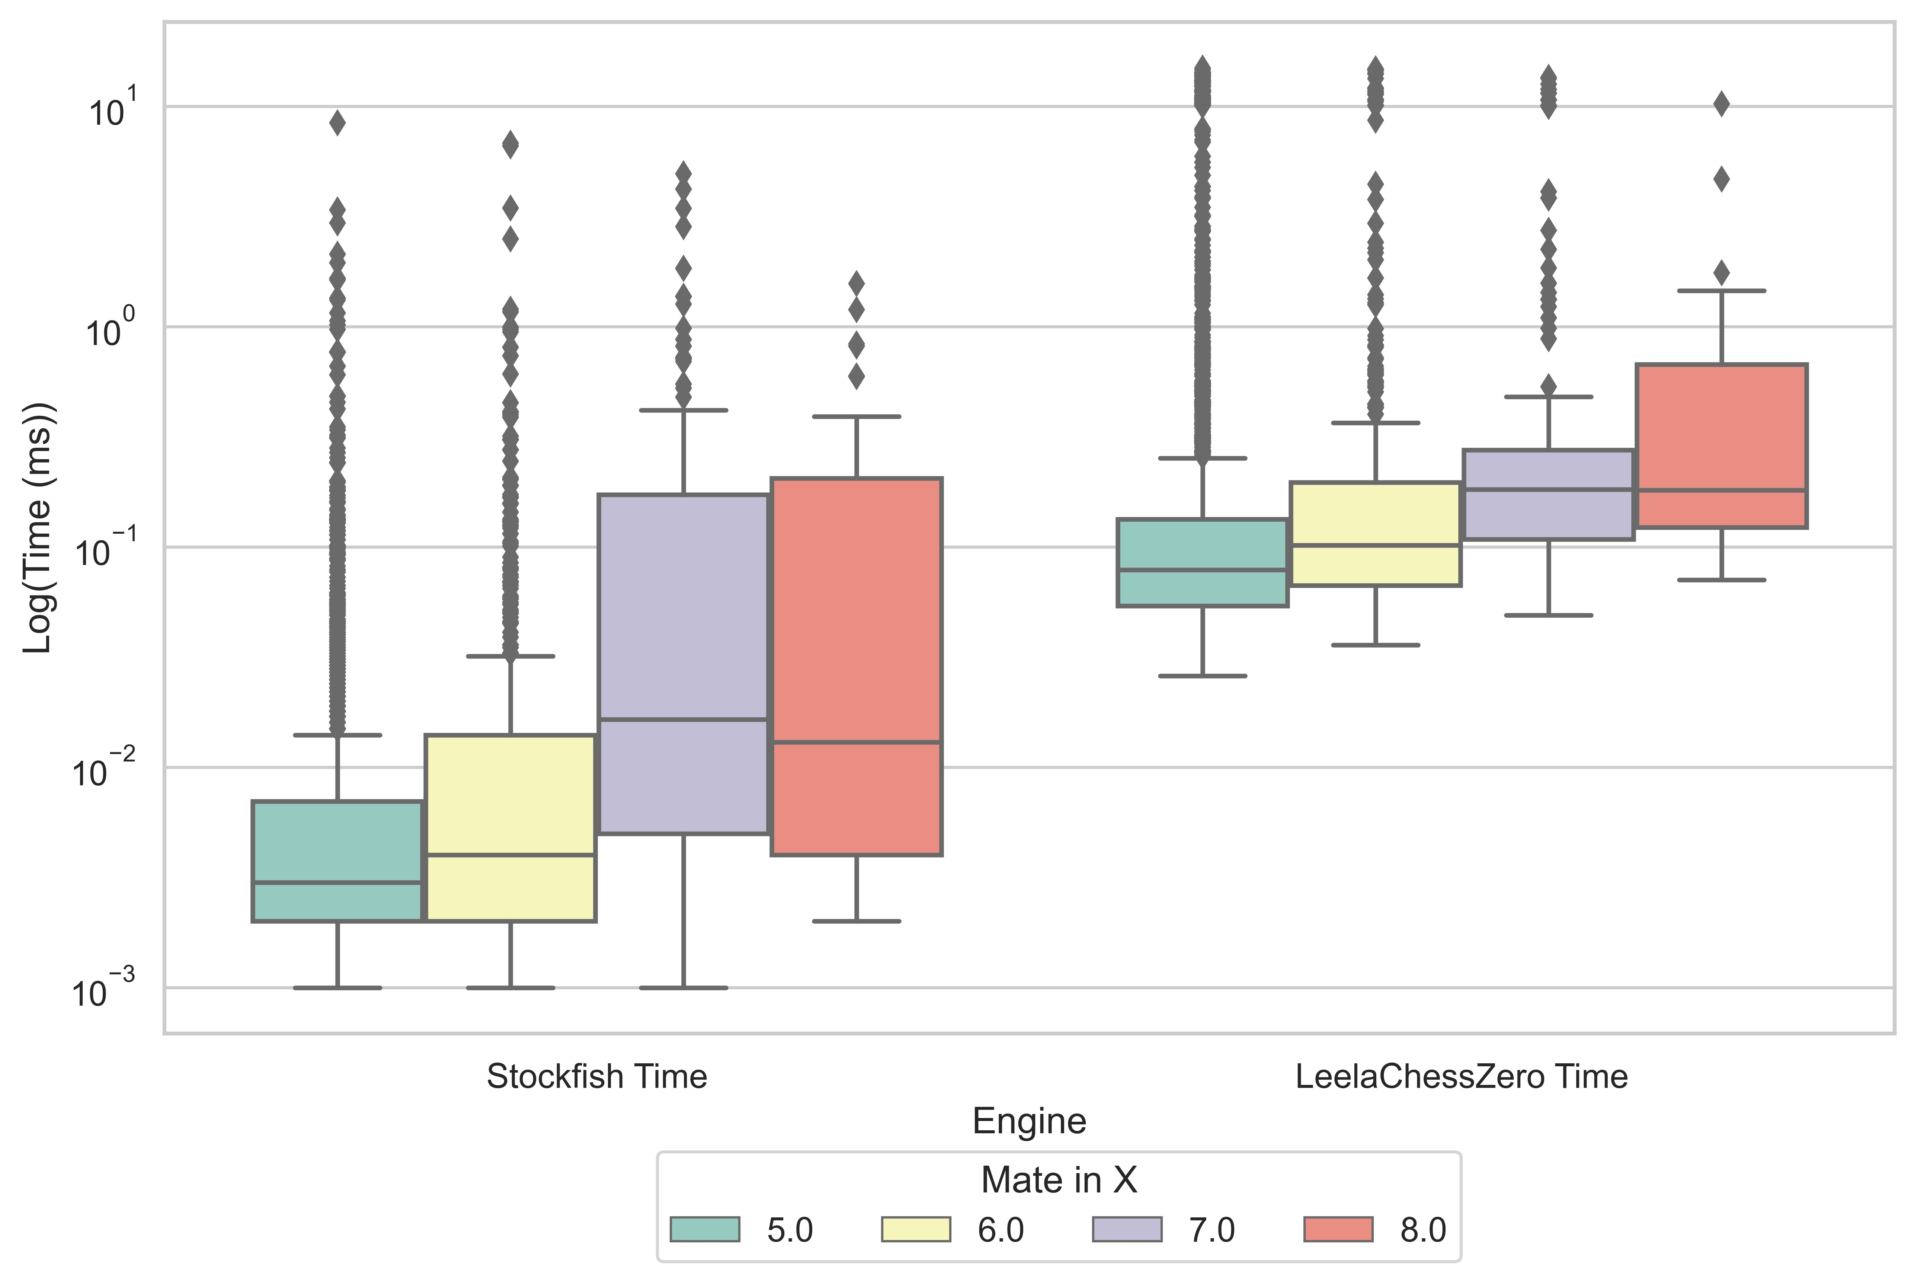

Figure 2 - Seldepth Comparison of Stockfish and Leela Chess ZERO

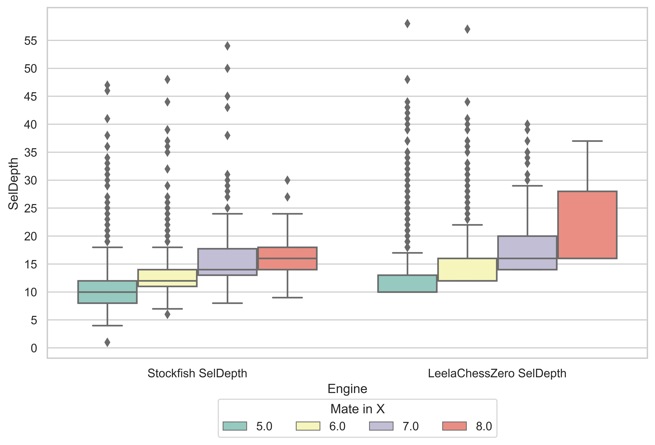

Figure 3 - Nodes Comparison of Stockfish and Leela Chess ZERO

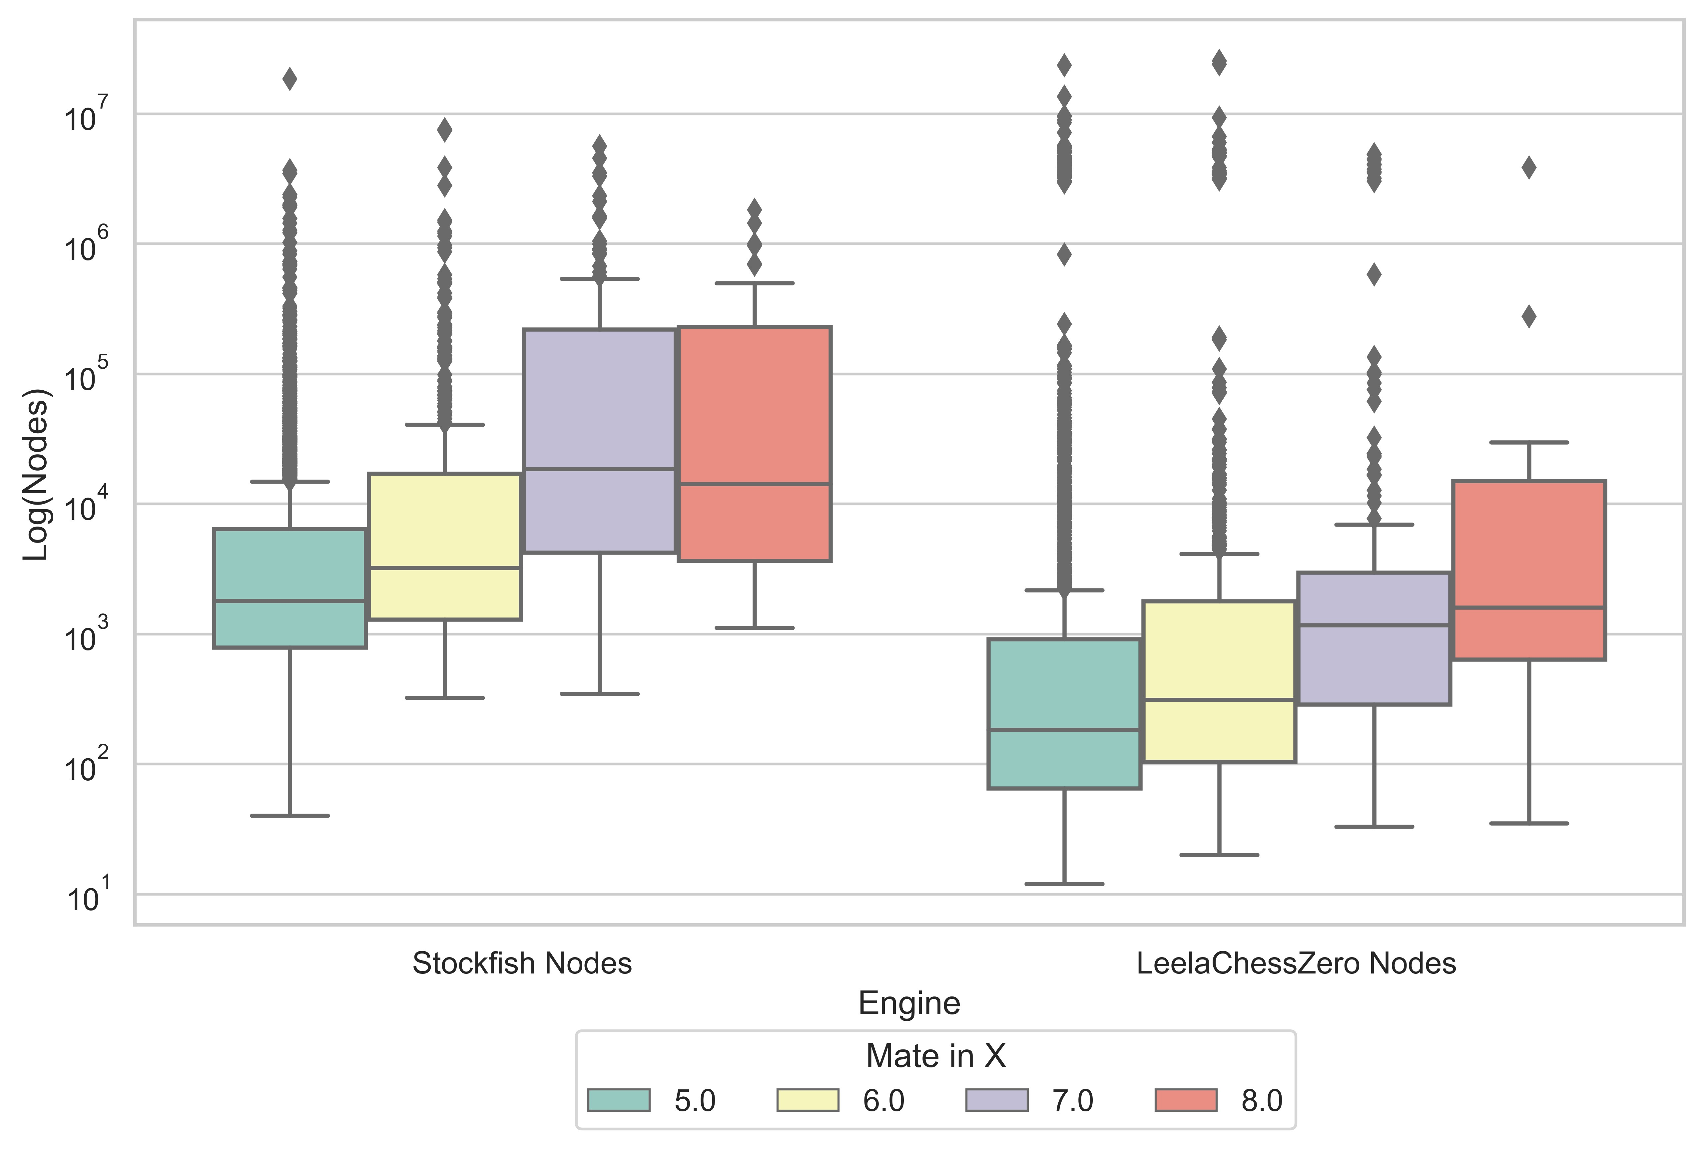

Along with the median difference for *time* and *seldepth*, the minimum values required for Stockfish to identify the mating pattern required with *time* being an order of magnitude lower and *seldepth* being half or less of Leela Chess Zero’s for three out of four mate pattern lengths,

## 6.2 Player Opening Distribution Analysis

### 6.2.1 Diversity Distribution

The initial analysis of the players by Gini Index and Shannon Index diversity metrics revealed an optimal cluster number *k* of 3.

Figure - K Value Assessment for Diversity Clustering

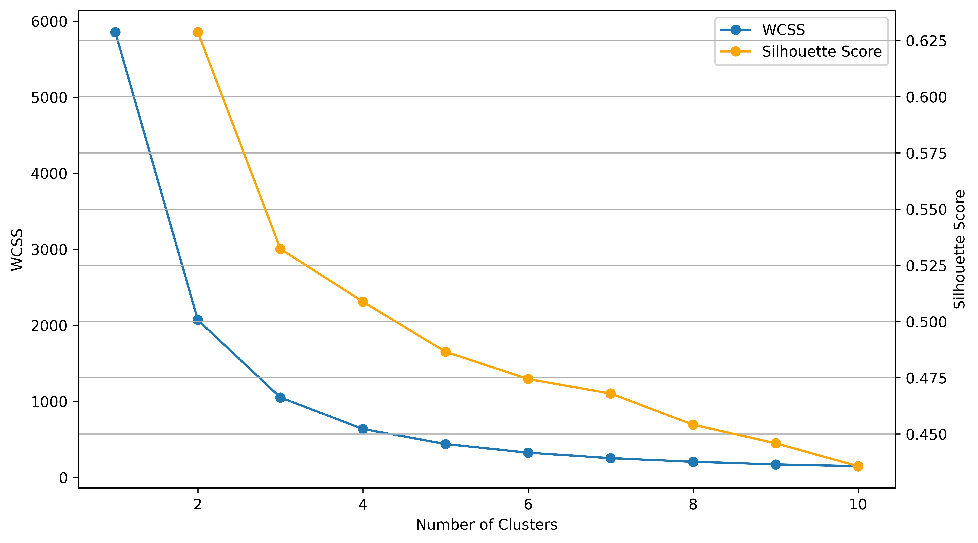

With this number, the k-means clustering returned clusters that, when used to display both the Gini and Shannon Indexes by density, show three distinct clusters.

Figure - Shannon Diversity Clusters

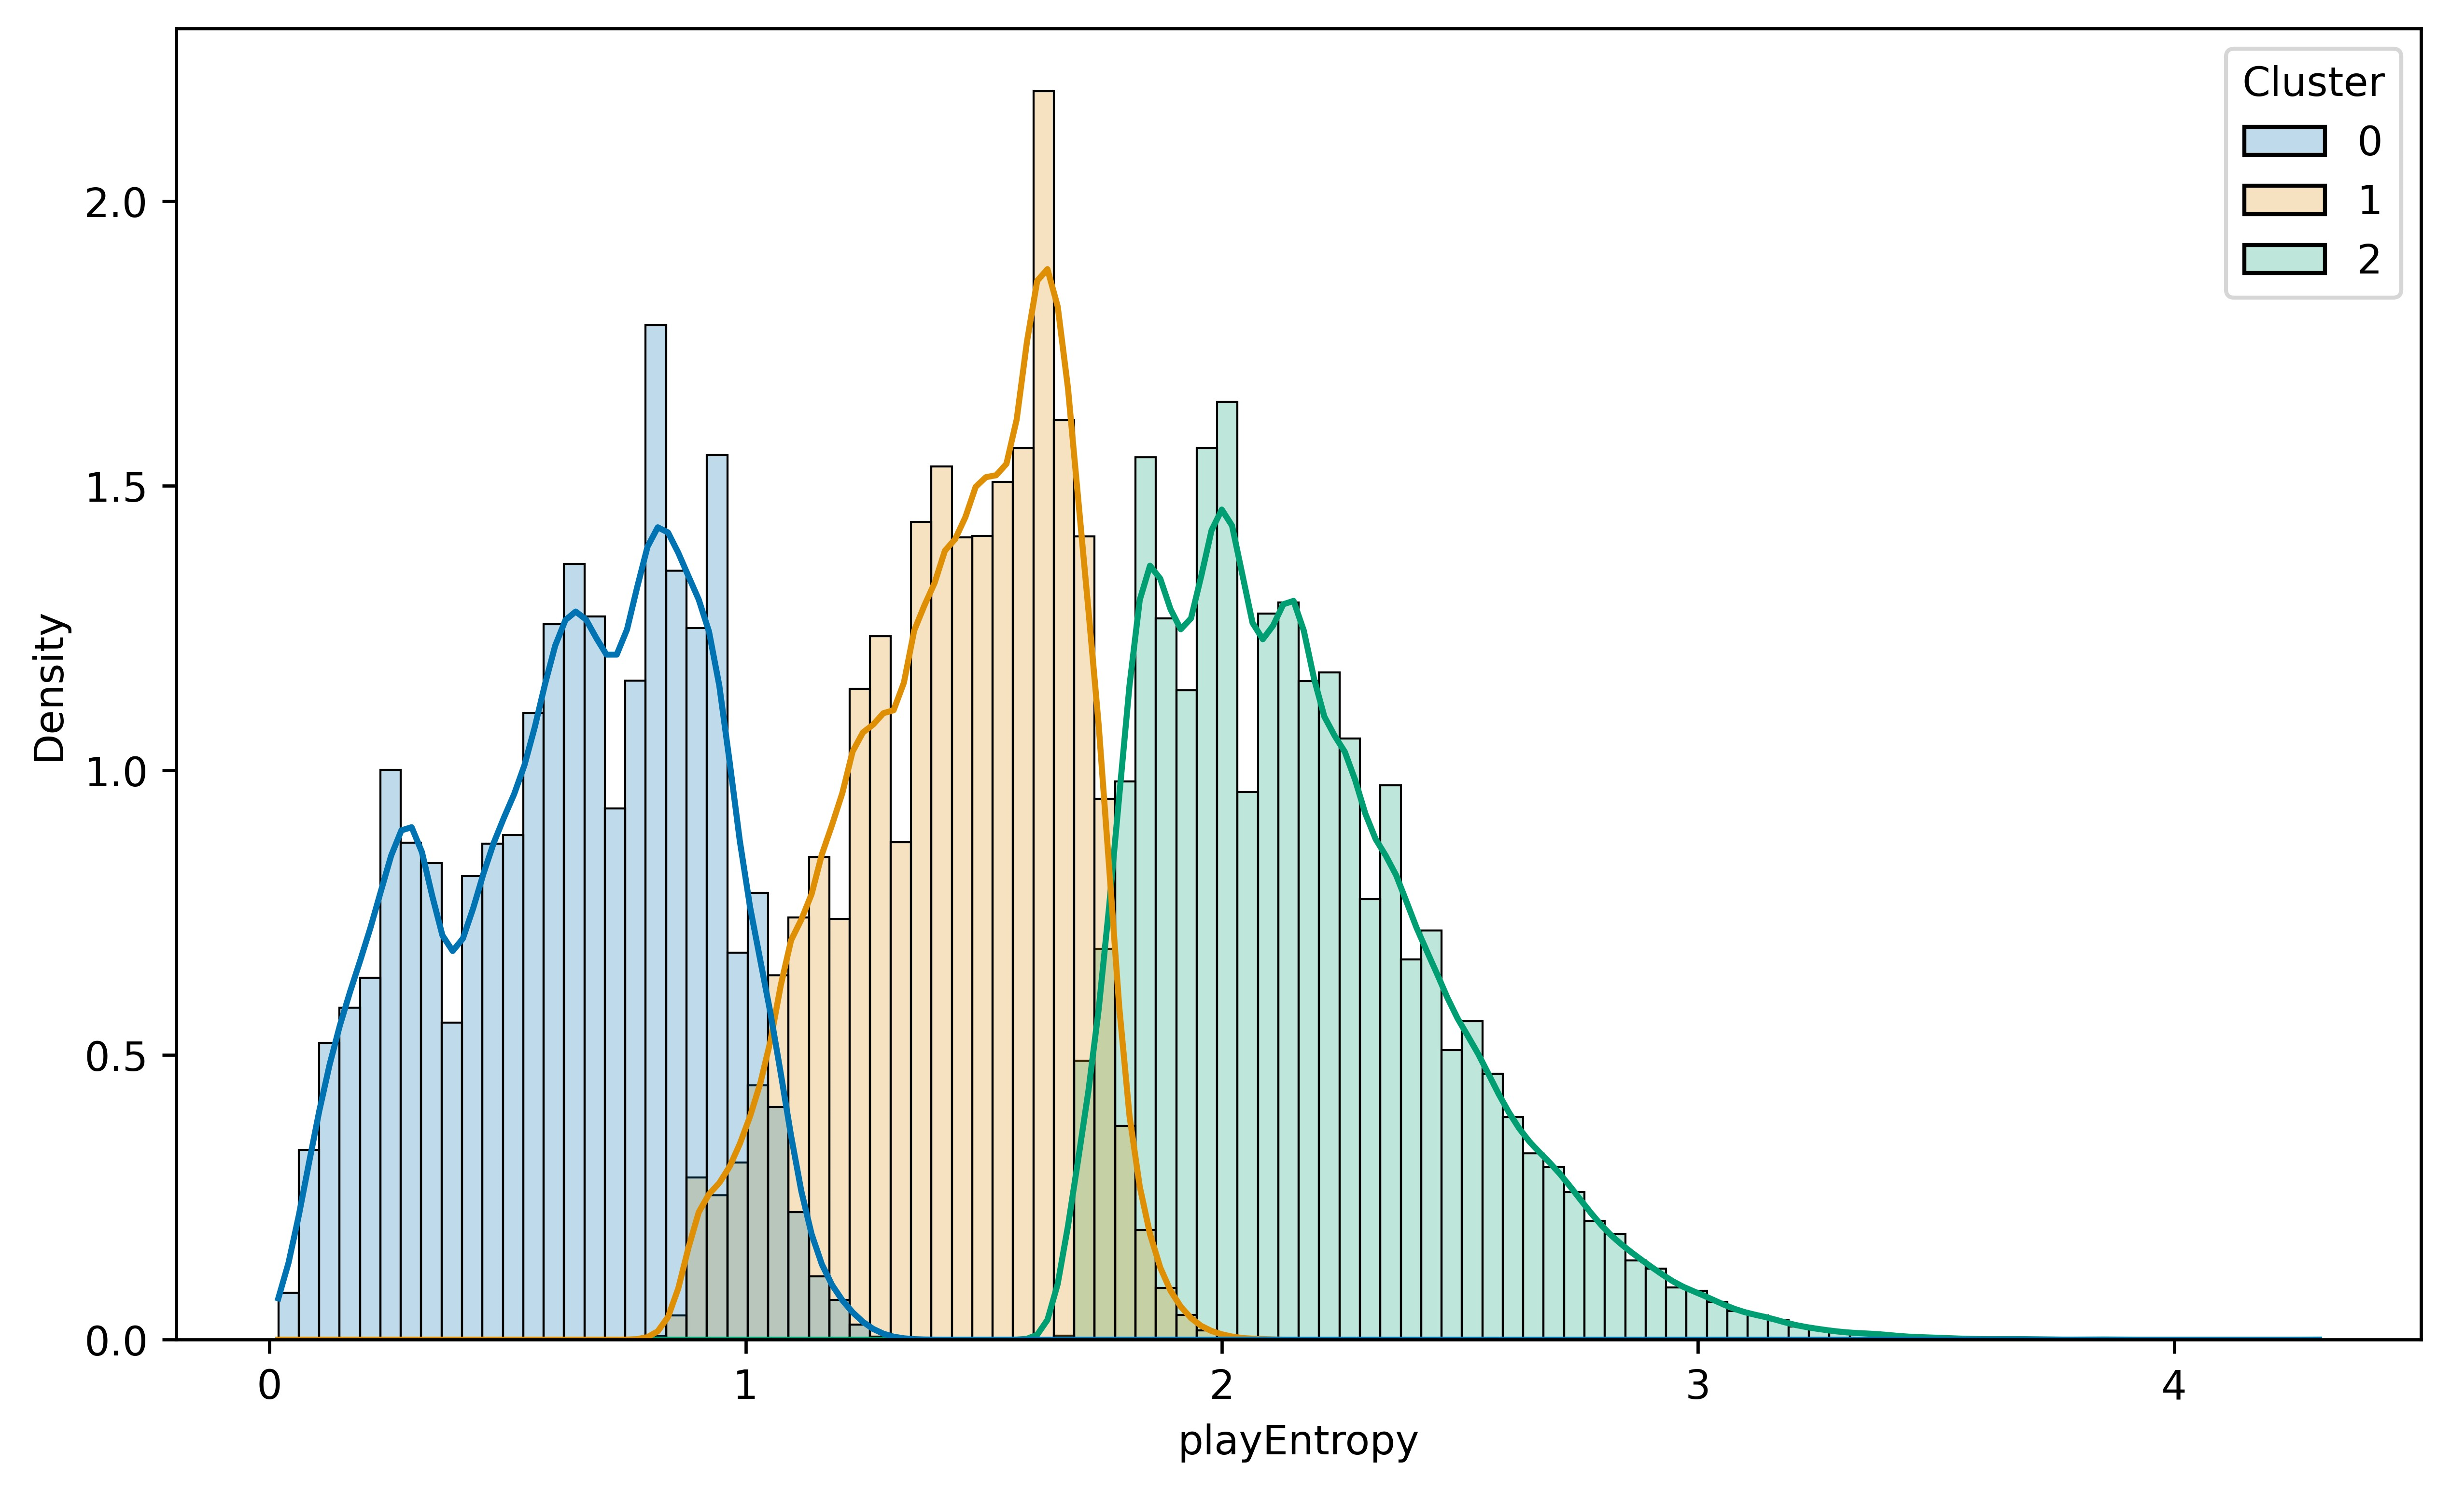

Figure - Gini Diversity Clusters

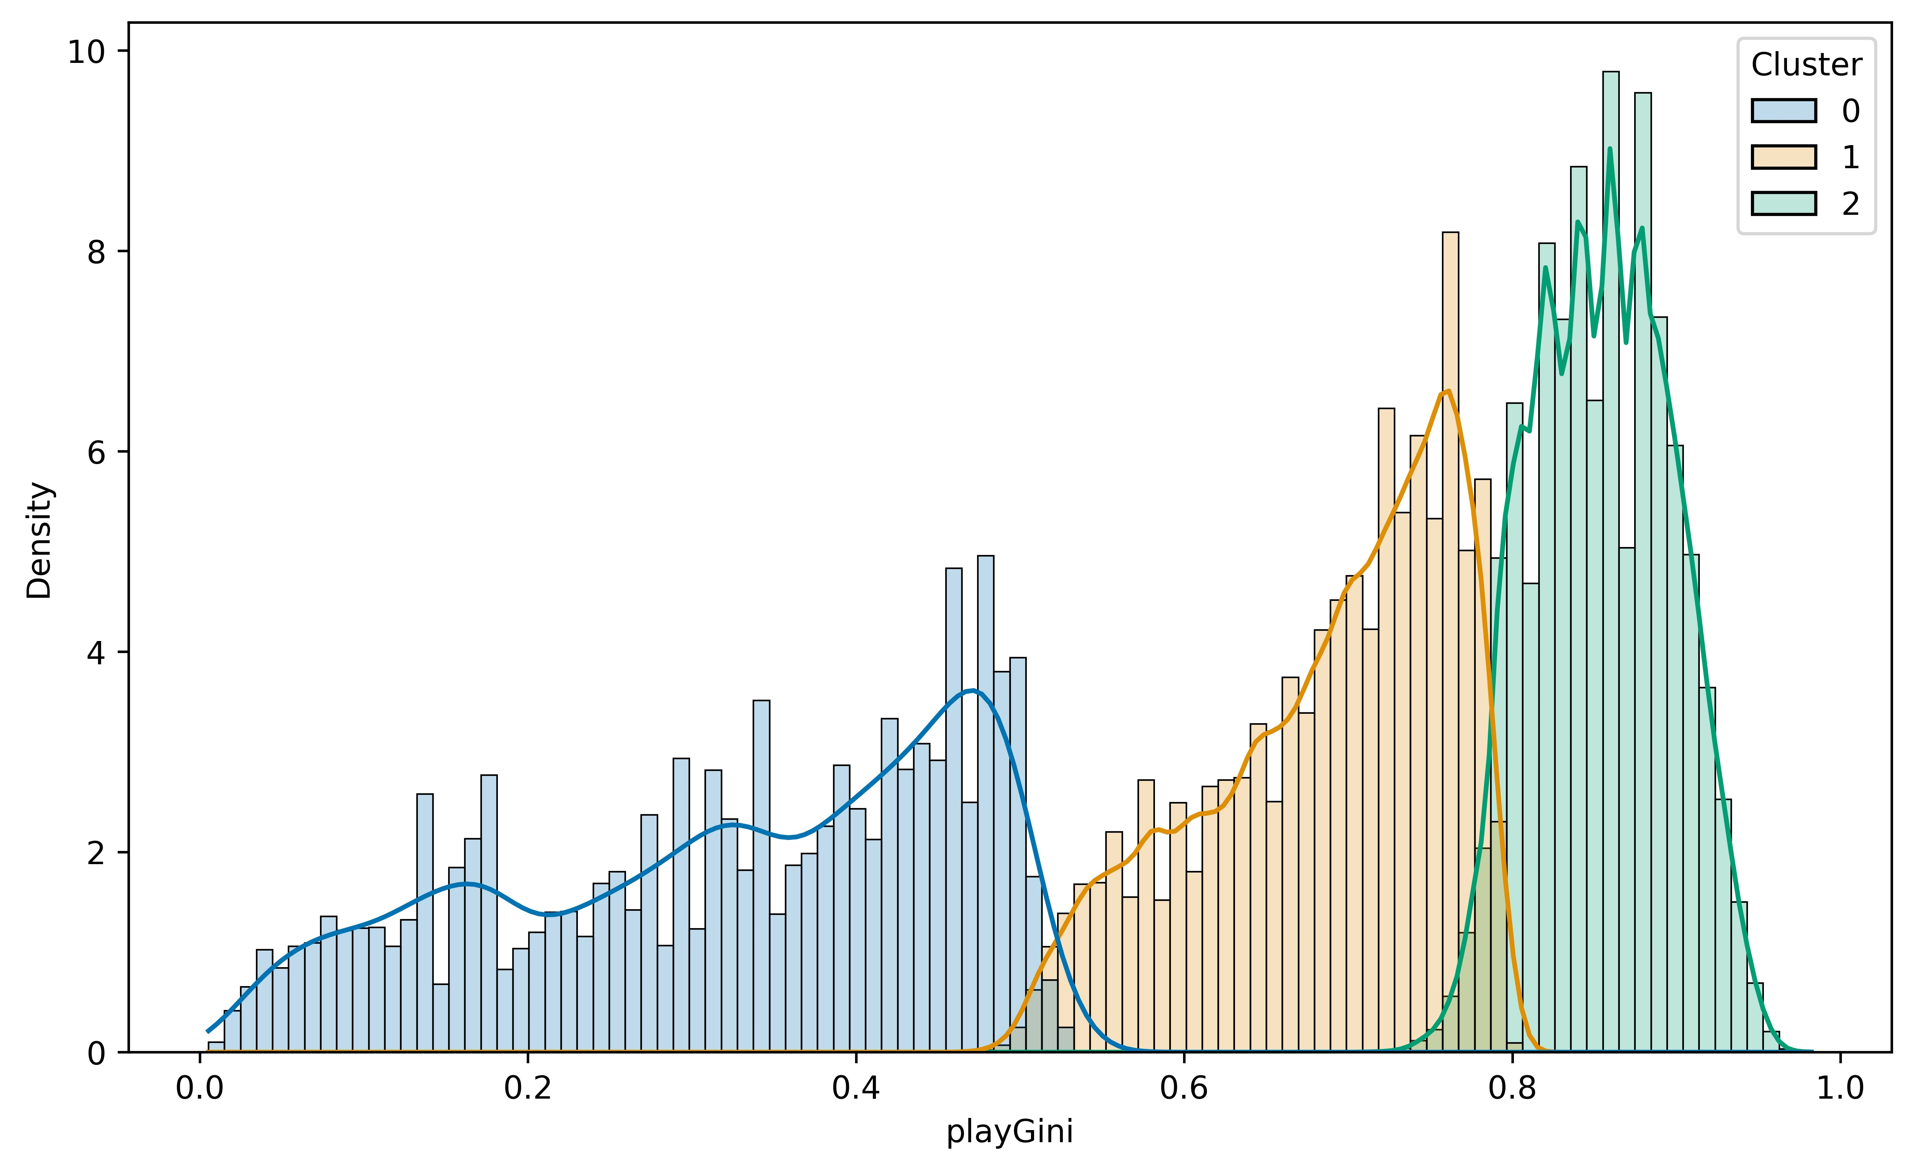

With these clusters, the count of players could be displayed. This indicated that there are no distinct groups by rating based on diversity metrics. With this, it can be concluded that within this sample of players, there is a range of diversity selection within the population concerning player ratings. Below, a histogram shows the number of players divided by clusters based on diversity indexes. The stacked histogram shows a normal curve, as expected, with a measurement of rating at a population level. In this graph, the three distinct populations sit atop one another showing extreme overlap. The implication of this is that three groups of players are selective of their openings in different ways, but these groups contain players from wide ranges of ratings.

Figure - Diversity Clusters by Rating

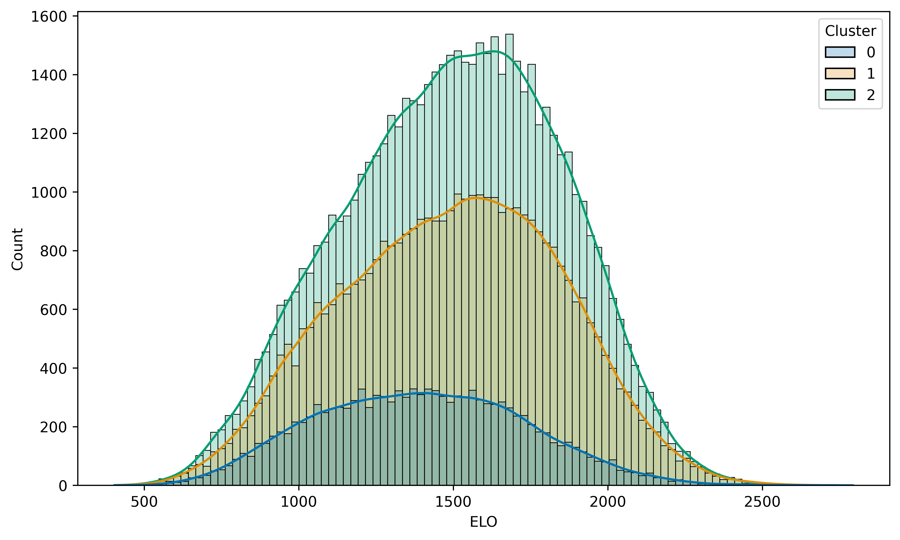

### 6.2.3 Distinction in Opening Repertoire

Following this, the nearest neighbour clustering analysis for determining player similarity in repertoire was performed. As before, an initial clustering to determine the optimal *k* value for the k-means clustering showed three distinct clusters. This can be seen below with a distinct elbow for the within-cluster sum of squares appearing when k equals 3.

Figure - K Value Assessment for Opening Choice Clustering

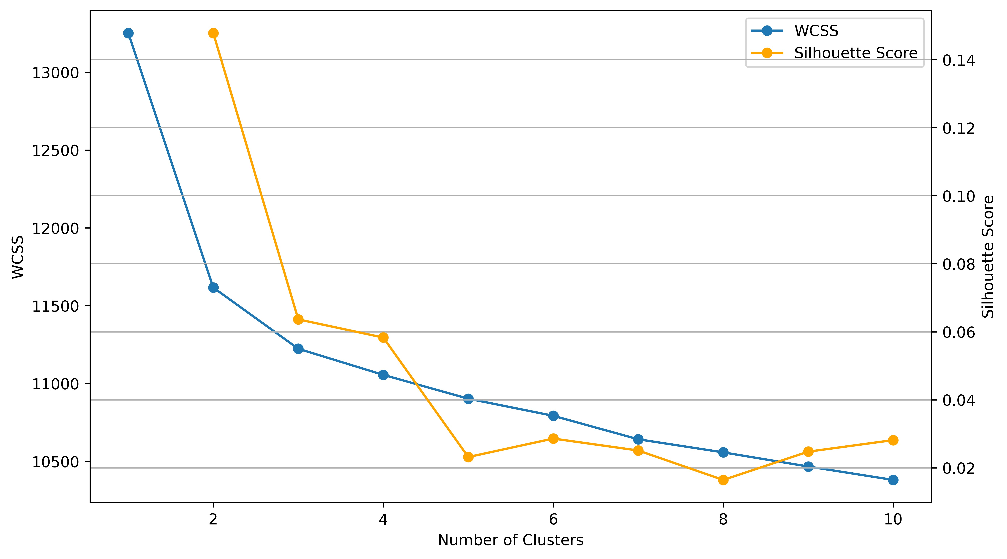

With this *k* value a clustering, the count-encoded clusters were established and analysed where three distinct populations were found. Below, a stacked histogram shows the clustering result plotted by player rating.

Figure - Opening Choice Clusters by Rating

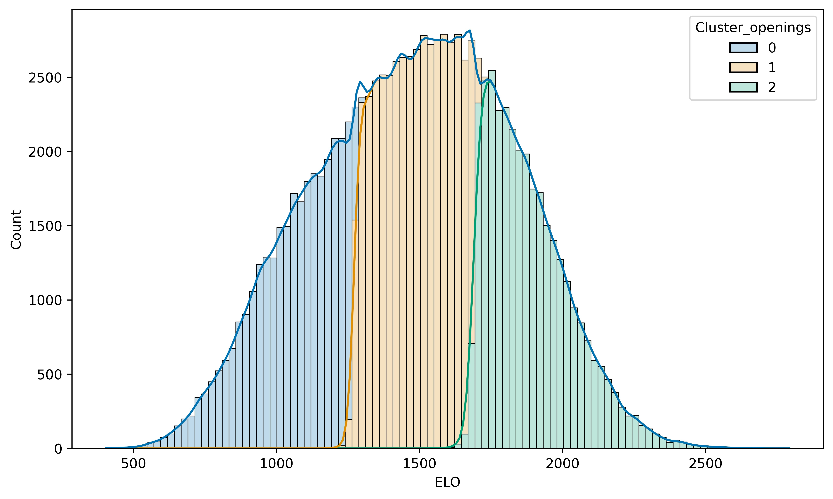

From this, it’s clear there are distinct rating points at which the players tend to select openings from different pools. There is some slight overlap, which is anticipated as player rating based on Gecko ELO is a sliding scale, with players often moving up and down throughout several games.

With this, the cluster values for players can be fed into the proposed recommendation system. From there, the differences in recommendations based on player similarity or success with specific openings can be compared to that of recommendations based on players that choose from similar openings with neighbouring ratings.

## 6.3 Engine Analysis of Openings.

With the positions analysed at the end of the opening and every five successive white moves up to 15 moves, a comparison of these with the Win/Loss ratio of the openings was performed. The first assessment considered is the correlation analysis, which showed some similarities in the 0th move position and the 5th move position with the Win/Loss ratio.

Figure - Correlation Heatmap of Engine Evaluations

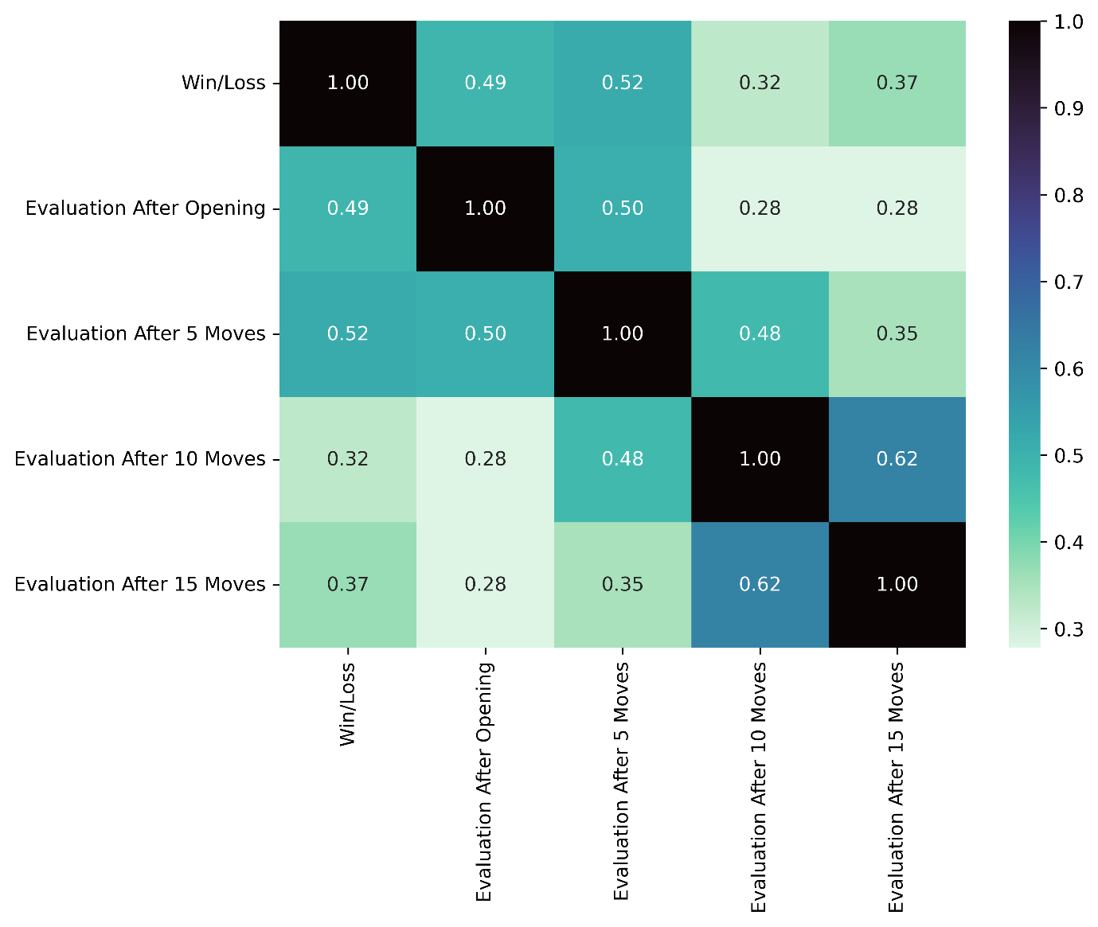

The Pearson Correlation value of 0.49 and 0.52 for the win/loss ratio to the evaluation at the opening and five moves after, respectively implies a minor relationship between the variables. Another critical correlation here is the value of 0.62 between 10 moves post-opening, and 15 moves post-opening, indicating there may be a point post-opening where engine evaluations stabilise.

Following this, to understand the relationship between the evaluations and the win/loss ratio, the linear regression was performed with the following results.

Figure - Results of Regression Analysis on Engine Evaluations

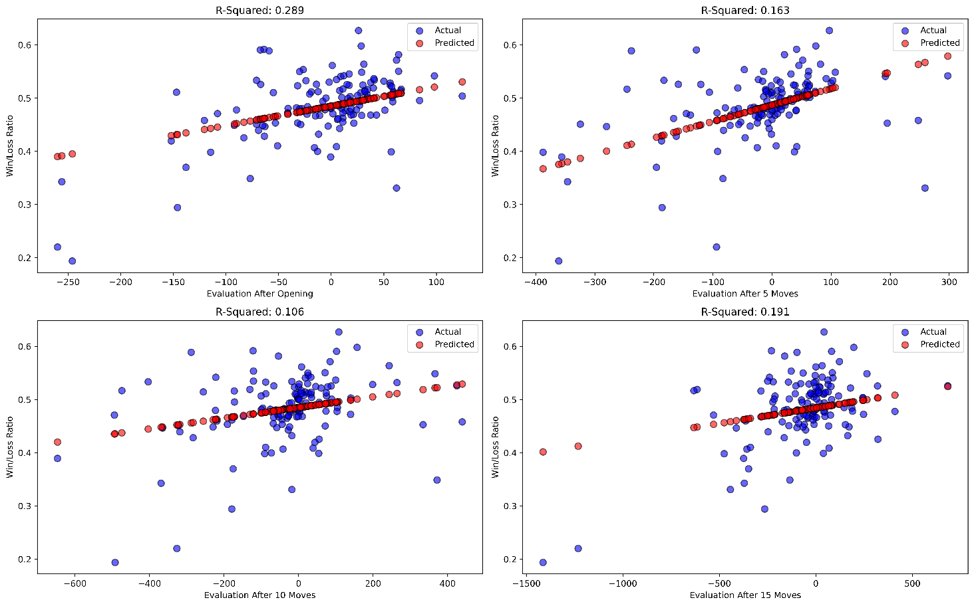

There appears to be a minor trend for the evaluations at each of the 4 analysis points. Despite this, with R2 values ranging from 0.106 to 0.289, this trend is minimal.

## 6.4 Recommendation System

The nearest neighbour recommendation system evaluated the 10 top recommendations for each player based on various metrics. Two heatmaps were generated based on the Jaccard similarity and the Sequence similarity. The heatmaps display each combination of recommendation metrics along with the cluster/non-cluster-based recommendations.

Figure 12 - Jaccard Similarity of Recommendations

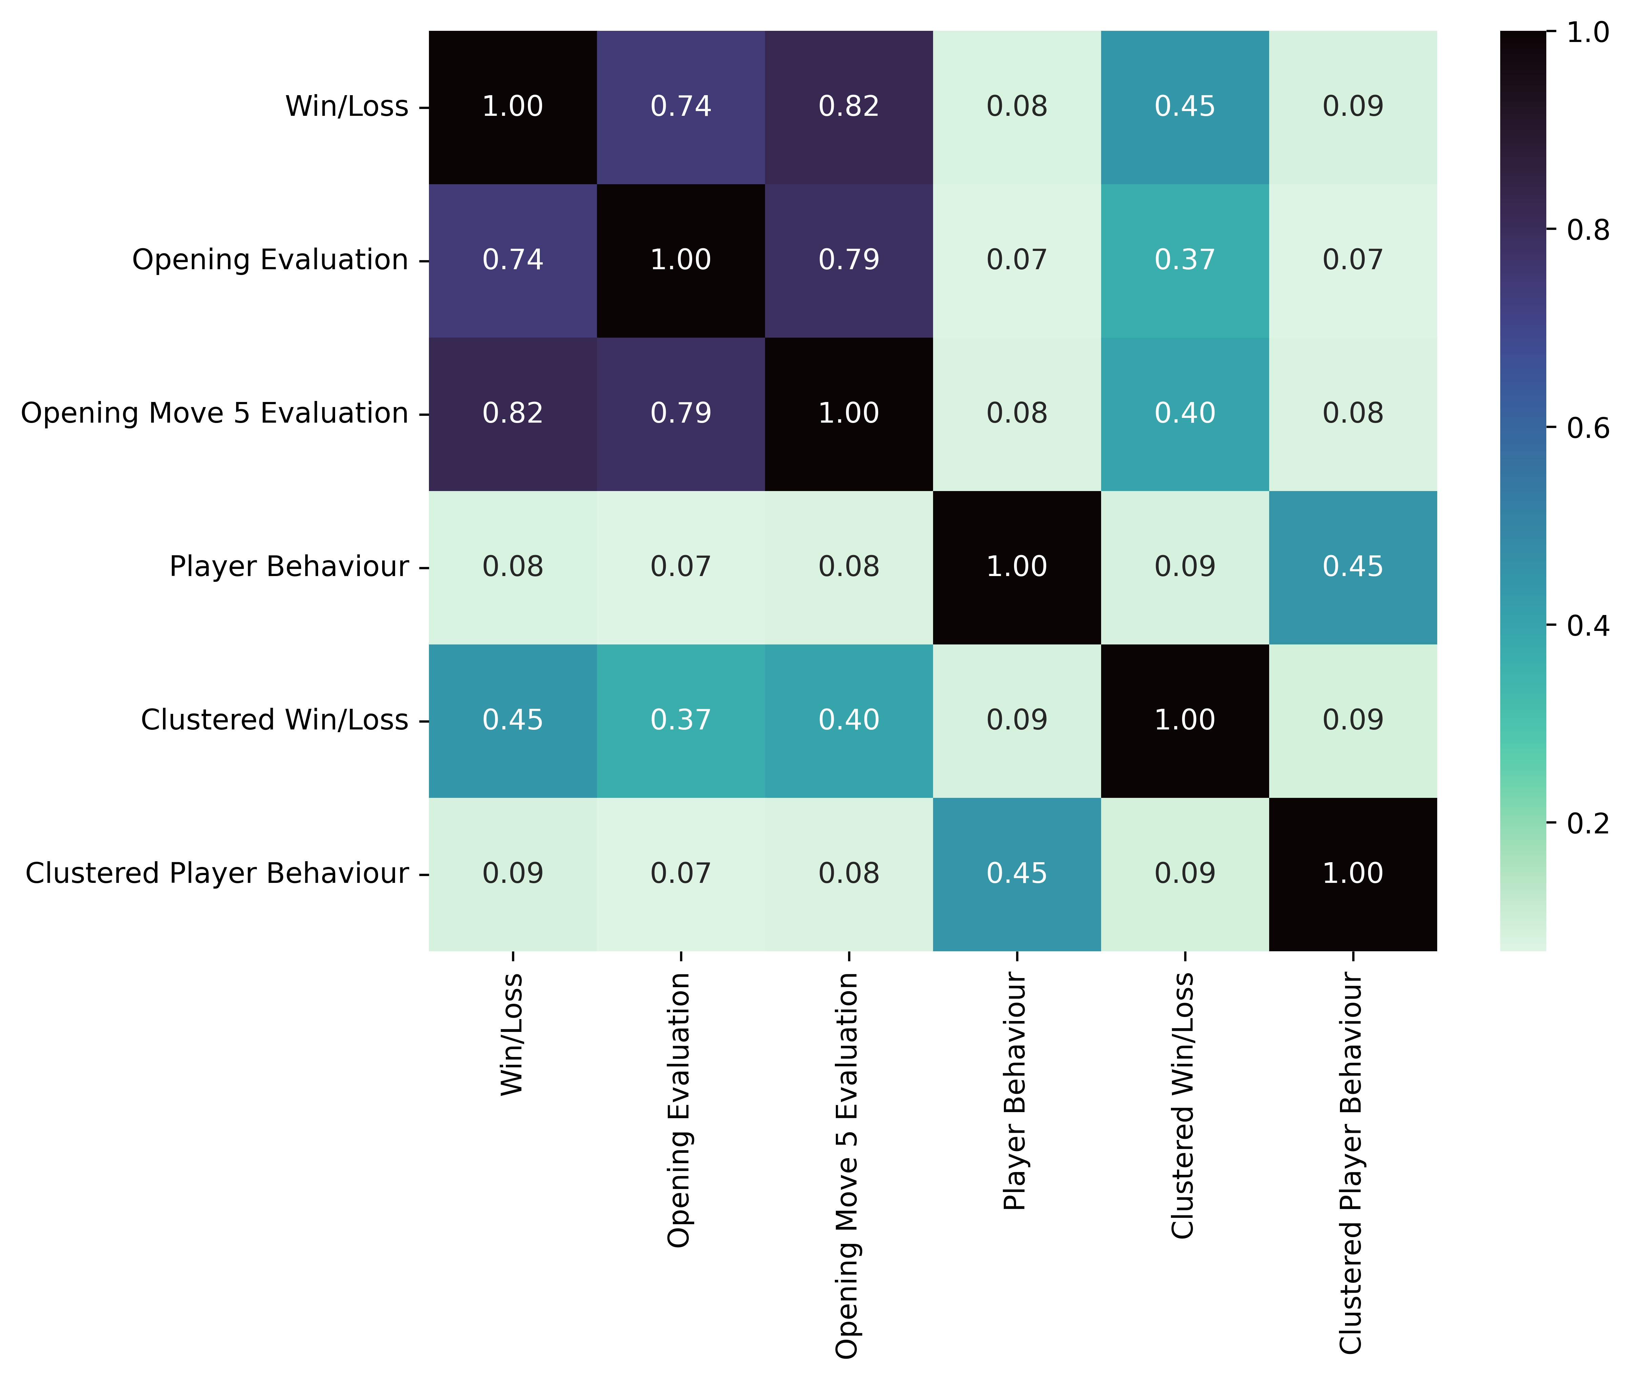

The Jaccard similarity shows that the end of the Opening evaluation and the 5 Move evaluation are highly similar to the Win/Loss ranking metric for the evaluation of players. Notably, the clustered recommendations for both the Win/Loss player success ranking and the player behaviour nearest neighbour recommendations have an overlap similarity of 0.45. Player behaviour recommendations have an overall lower similarity with the ranking metrics with values of 0.07 with evaluation at opening and 0.08 with both Win/Loss ratio and 5 Move evaluation.

Figure 13 - Sequence Similarity of Recommendations

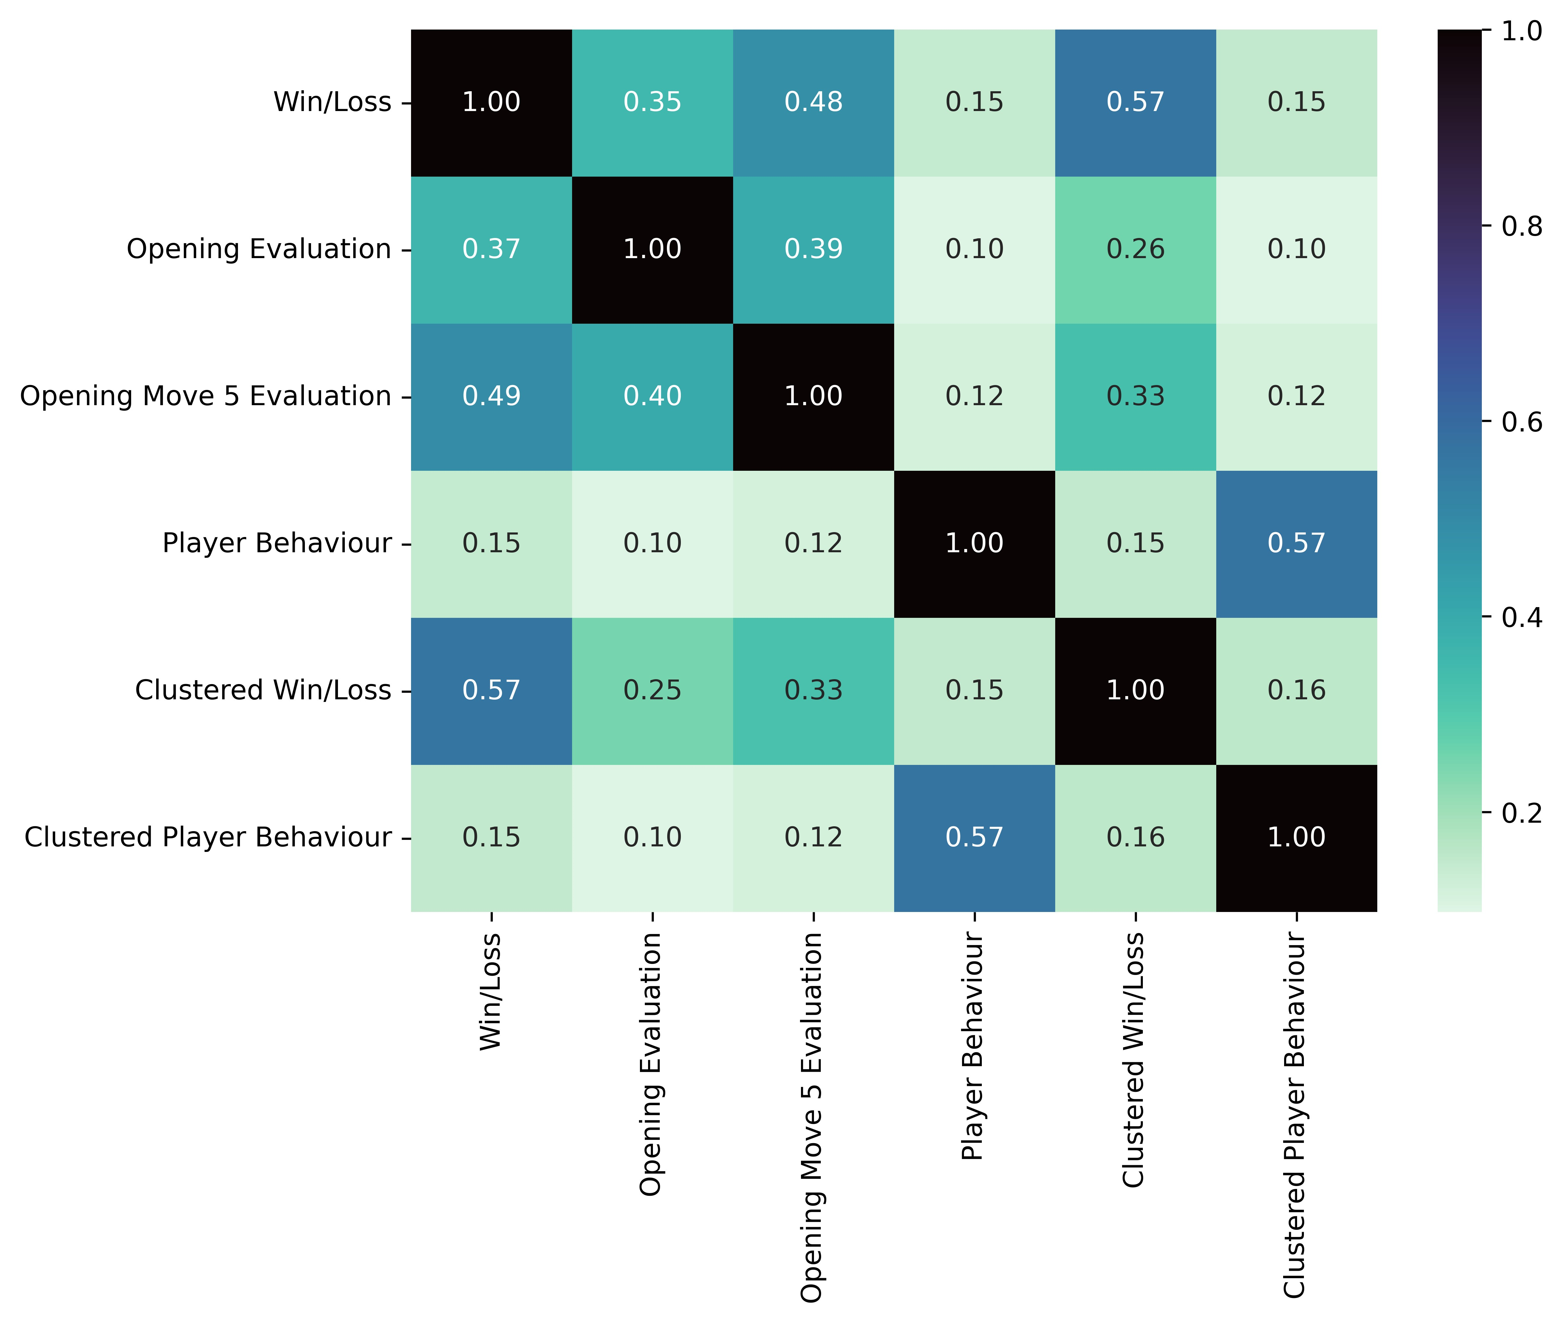

The Sequence similarity provides insight into ordering similar recommendations within each player's outputs. As for the Jaccard similarity, the clustered recommendations show equal similarity with their non-cluster counterparts. Overall, the similarity values are lower when compared to Jaccard. This is not unexpected and shows that although the recommendations may overlap, the point at which they are recommended in the lists by valuation is not as consistent. As with Jaccard similarity, player behaviour similarities are low with values of 0.10 and 0.12 with evaluation at opening and 5 Move evaluation, and 0.08 with Win/Loss ratio.

# Chapter 7: Discussion

The research and analysis in this paper has demonstrated the role chess engines can have as data analytics tools on the game of chess, rather than on the individual game analysis level. By using engines on an aggregated dataset level,

The complexities of understanding players with respect to how they interact with openings has been investigated and demonstrated with linkage between a player’s rating and the opening they may be more inclined to choose.

Combining this information has given rise to a collection of recommendations, wherein the player specific recommendations can be compared based on the metric used for each system in the collection. In this discussion section, the results of the research that was completed will be discussed and broken down by their implications with respect to the objectives set out in in the initial stages of this project.

## 7.1 Puzzle Analysis

The results obtained from using the chess engines Stockfish and Leela Chess Zero, two of the top open-source engines competing in the Top Chess Engine Championships, has shown indications of power gain in selecting the correct tool for a *Mate in X* analysis. This test aimed to determine the chess engine which could provide more depth of search and overcome a potential limiting horizon to provide an evaluation that will be reflective of the current position.

By measure of *time*, *seldepth*, and *nodes,* Stockfish outperforms Leela Chess Zero with statistical significance. The boxplots showed a significant difference between them, allowing for a decision to choose Stockfish as the engine to gain an alternative insight into the value of openings.

The result seen here is in line with theoretical understanding of search algorithms (Maharaj, et al., 2022), with Stockfish having manually crafted heuristics to handle mating problems specifically. Leela Chess Zero, designed by a hands-off neural network approach, may not have encountered specific mating patterns in its training, with the game of chess having such a vast array of endgame combination possibilities. Stockfish’s performance lead on all the metrics considered showed its search performance has the ability to overcome the horizon effect. This is particularly evident in the *seldepth* value, where the boxplot shows many instances in which the engine found a solution at a depth that was lower than the expected depth required.

## 7.2 Player Opening Distributions

The objective of establishing the relationships between players and choice in openings was to provide a basis of understanding for dynamics of a recommendation system based on players with similar opening choice styles.

The outcome of the diversity index clustering to divide players by rating gave clear indication that there are select groups of players that have different opening choice tendencies. These players when split out by their rating showed little difference in rating, with the histogram showing diversity in opening choice being distributed throughout all ratings. With this in mind, the alternative grouping of players based on their selection of openings rather than how they select their openings was considered and investigated.

This alternative grouping, which utilised a k-means nearest neighbour clustering method, determined the similar players by grouping based on the players and the openings they used within this sample of games. The count-encoded data fed into the machine learning algorithm produced three distinct clusters, the same value seen above in the diversity index assessment. Unlike the previous analysis though, when displayed by rating, three distinct clusters with only minor overlap were determined to exist.

This was a critical piece of information with respect to building a recommendation system and had to be considered. The main driver for this consideration as part of the recommendation system development was to minimise the recommendations for players that may be considered outside of the realms of choice if they independently chose new openings for their repertoire.

## 7.3 Opening Engine Analysis

With Stockfish being chosen as the preferred engine for this analysis, the objective of determining evaluations for opening positions and the five move intervals following was addressed. This objective is where we can see the use case of engine analysis as an alternative method to evaluate openings rather than taking the win loss ratio as a statement of fact for the potential success.

The correlation analysis of position evaluation reveals a minor correlation between the position evaluation at the end of an opening play and 5 moves after. A further investigation into the relationship between these variables shows a minor positive trend indicating with r2 values of 0.289 and 0.163. These values may indicate more decisive value to the win/loss ratio in terms of representing the openings on a player aggregate scale but are exclusive of the idea of opening theory. The benefit here of understanding the aggregated engine evaluation, is that engines can determine lines of play which are likely to provide minor benefits to player position.

When it comes to considering an opening based on the engine evaluation, these minor increases in position or piece advantage can have a significant impact on a game while only having a minor impact on the evaluation score. The implication is that openings chosen based on engine evaluation may be subject to more theory, which studious players could take advantage of when facing opponents that are less inclined to investigate theoretical outcomes of a positions.

## 7.4 Recommendation System

The final proposed objective in this project is a culmination of the previous objective outcomes. The recommendation system that was produced and evaluated considered the best engine for engine evaluation of openings; the evaluation of openings from the preferred engine; and the clusters that may provide players with openings that are more in line with their current repertoire.

The approach of extracting similarity measurements based on a numeric overlap and ranked ordering gave way to an interpretation that is multi-dimensional. The Jaccard Similarity rating between the Win/Loss ratio and the Opening and 5 Move evaluations indicates a high overlap with values of 0.74 and 0.82 respectively. This result combined with the Sequence similarity metrics of 0.37 and 0.49 respectively shows that multiple openings, between 7 and 8 out of 10, are recommended based on a players historical success with openings. By using these metrics, a potentially stronger recommendation for a player based on multiple values could be given with the implementation of a hybrid model. The benefits of using a chess engine, a tool typically used on an individual level, as a data analytics device can been seen here. With recommendations based on a players success being backed by the current most powerful chess information producer (Wiki, 2023), a player can be more confident of their decision to test a new opening.

Another section of the recommendation system developed indicates an exciting approach for recommenders in the form of the clustered based outputs. These outputs reveal an overlap of between 3 and 5 openings with both the Win/Loss recommendations and the opening evaluation recommendations. Players looking to expand their repertoire may not be inclined to diverge from the comfort of knowledge. To bear this in mind, this overlap means a multi-metric-cluster based recommendation system, combining all the recommendations of openings with the best chances of winning without deviating from the sets openings played by players within a cluster.

Finally, the player behaviour shows an average overlap of less than 1 with each of the systems developed before. This provides a unique alternative angle for a players approach in choosing an opening as it may not be the best opening based on other players that had success with similar repertoires. This method gives player’s a chance to explore their play style and how they like to attack, defend, or implement tactics.

This section has shown not only how extracting the apparent minimal data of players, openings, ratings, and their moves can lead to the development of a system that can benefit the player; but also, how using a complex analytical engine can boost such a system and provide confidence with respect to the outputted recommendations.

# Chapter 8: Conclusion

In this paper, the process of determining the chess engine with the best potential for handling the horizon effect was determined by comparing the engine parameters at which a *Mate in X* was solved. The analysis showed Stockfish to outperform Leela Chess Zero for this use-case which informed the decision of using it as the chess analytics tool for the evaluation of openings positions. The collection of openings extracted and filtered provided sufficient basis for establishing evaluations based on the progression of chess games. An exploratory process gave way to the determination of dynamics between a player’s rating and their relationship with specific pools of openings. The culmination of the objectives set out in this research resulted in a collection of recommendation systems that provide orthogonal approaches in the expansion of an opening repertoire for chess players.

The use of chess engines as a tool to provide informative analytics was the fundamental inspiration driving the objectives formulated in this project. The practical integration of engines within data analytics has been thoroughly investigated. With the results observed in this project, this project has been able to contribute a broader understanding of engine-driven analytics within recommendation systems. This offers a comprehensive perspective that can provide benefits to both beginner players and long-time enthusiasts alike.

Although the objectives set out for this research have been fulfilled, limitations occurred during the analysis that must be addressed.

The consideration is that of granularity. Even with 10 million games extracted from the chess game database, some of the more complex, theory-specific openings only occurred with low frequency. These openings are identified with the *Variation* section of the name, with some having 2+ variations in their assigned name. Without a sufficient sample of these openings, they could not be included within a recommendation system as the aggregation values of both win/loss ratio and chess engine evaluation may not have been reflective of the real-world values. This element could be addressed with a more purposive sampling method such as a stratified approach. This would involve the database being processed on a game by game basis rather than collectively, which could provide the solution of skewed sampling without the reduction of granularity.

The second point to consider when reviewing the results of this research is the application of the analytics engines to the chess openings. In order for an engine to analyse a position thoroughly, it may need to be run for excess amounts of time. With time constraints being a factor for this analysis, a limit of 1 second was required for each game analysis. While this sounds like a small amount of time, engines often perform accurately with these limitations, but it introduces an element of the horizon effect. The evaluation of the optimal engine for this research was intended to mitigate this, but by allowing an indefinite analysis until stabilization, given sufficient time, the most reflective engine analysis possible could be achieved.

Future scope for the results of this project is that of the beneficial incorporation of chess engines as tools within large scale chess data analytics. Further scope identified is the combining of recommendation systems to implement a real world use case for large scale data analytics within the chess environment outside of standard game analysis. It has been demonstrated that chess is a complex task to analyse, and the specialised engines can process mass amount of data with such ease that when considering future chess related research there is a place for their function. Leveraging the Lichess API, a practical deployment of both the clustering models and the recommendation systems would be the next natural step to allow players to generate custom recommendations.

This development of alternative recommendation systems based on historical data and chess engine evaluation provides a platform at which the worlds of chess specific machine learning and broader data analytics machine learning can be integrated. This combined approach has the potential to increase the scale at which chess data can be analysed and to produce tools that yield benefits for chess players of all abilities.

# References

Alvi, M., Ferlito, G. & Sanvito, A., 1990. On the Origins of Chess.

Anelli, V. W. et al., 2022. *Top-n recommendation algorithms: A quest for the state-of-the-art.* s.l., s.n., pp. 121-131.

Anon., 2019. Sequence similarity searchin. *Current protocols in protein science,* 1(95), p. e71.

Authors, L., 2023. *Blog.* [Online]   
Available at: https://lczero.org/blog/  
[Accessed 17 05 2023].

Bag, S., Kumar, S. K. & Tiwari, M. K., 2019. An efficient recommendation generation using relevant Jaccard similarity. *Information Sciences,* 489(53).

Bau, D. et al., 2020. Understanding the role of individual units in a deep neural network. *Proceedings of the National Academy of Sciences,* 117(48), pp. 30071-30078.

Bau, D. et al., 2020. Understanding the role of individual units in a deep neural network. *Proceedings of the National Academy of Sciences.*

Berg, A., 2020. Statistical Analysis of the Elo Rating System in Chess. *CHANCE,* 33(3), pp. 31-38.

Bhowmick, H., Chatterjee, A. & Sen, J., 2023. *Comprehensive Movie Recommendation System.* s.l.:s.n.

Borovska, P. & Lazarova, M., 2007. Efficiency of Parallel Minimax Algorithm for Game Tree Search. In: *Proceedings of the 2007 International Conference on Computer Systems and Technologies.* Bulgaria: Association for Computing Machinery.

Brudno, A., 1963. Bounds and valuations for shortening the search of estimates. *Problems of Cybernetics,* Volume 10, p. 225–241.

Chaslot, G. M. J. et al., 2008. Progressive strategies for Monte-Carlo tree search. *New Mathematics and Natural Computation,* 4(3), pp. 343-357.

Chowdhary, S., Iacopini, I. & Battiston, F., 2023. Quantifying human performance in chess. *Scientific Reports,* Volume 13.

Clough, J. R. et al., 2019. Global and Local Interpretability for Cardiac MRI Classification. In: D. Shen, et al. eds. *Medical Image Computing and Computer Assisted Intervention -- MICCAI 2019.* s.l.:Springer International Publishing, pp. 656--664.

Daskalakis, C., Goldberg, P. W. & Papadimitriou, C. H., 2009. The Complexity of Computing a Nash Equilibrium. *SIAM Journal on Computing,* 39(1), pp. 195-259.

De Marzo, G. & Servedio, V. D. P., 2023. Quantifying the complexity and similarity of chess openings using online chess community data. *Scientific Reports,* 13(13), pp. 2045-2322.

developers, T. S., n.d. *Official Stockfish - Github.* [Online]   
Available at: https://stockfishchess.org/  
[Accessed 17 05 2023].

Dreiseitl, S. & Ohno-Machado, L., 2002. Logistic regression and artificial neural network classification models: a methodology review. *Journal of biomedical informatics,* Volume 35, pp. 352--359.

Dudek, A., 2020. Silhouette Index as Clustering Evaluation Tool. In: K. Jajuga, J. Batóg & M. Walesiak, eds. *Classification and Data Analysis.* s.l.:Springer International Publishing.

Edwards, S. J., 2003. *The On-Line Encyclopedia of Integer Sequences.* [Online]   
Available at: https://oeis.org/A048987  
[Accessed 24 09 2023].

Feller, J. & Fitzgerald, B., 2002. *Understanding open source software development.* s.l.:Addison-Wesley Longman Publishing Co., Inc..

Fisher, R. A., 1954. *Statistical methods for research workers.* 12th ed., rev ed. Edinburgh: Oliver and Boyd Edinburgh.

Ghorbani, A., Wexler, J., Zou, J. Y. & Kim, B., 2019. Towards automatic concept-based explanations. In: H. Wallach, et al. eds. *Advances in Neural Information Processing Systems.* s.l.:s.n., pp. 9273--9282.

Glickman, M. E., 1995. A comprehensive guide to chess ratings. *Glickman 1995 Comprehensive.*

Glickman, M. E., 1995. The Glicko System. *Boston University,* Volume 16, pp. 16-17.

Grodzinsky, F., Miller, K. & Wolf, M., 2003. Ethical issues in open source software. *Journal of Information, Communication and Ethics in Society,* Volume 1, pp. 193-205.

Guidry, M. & McClendon, C. B., 2009. Techniques to Parallelize Chess.

Hamzah, M., 2022. *Game Theory: How Stockfish Mastered Chess.* [Online]   
Available at: https://blogs.cornell.edu/info2040/2022/09/30/game-theory-how-stockfish-mastered-chess/  
[Accessed 17 05 2023].

Haque, R., Wei, T. H. & Muller, M., 2021. *On The Road To Perfection? Evaluating Leela Chess Zero Against Endgame Tablebases.* Virtual Event, Springer-Verlag.

Hauptman, A. & Sipper, M., 2007. Evolution of an Efficient Search Algorithm for the Mate-In-N Problem in Chess. In: M. Ebner, et al. eds. *Genetic Programming.* Berlin, Heidelberg: Springer Berlin Heidelberg, pp. 78--89.

Hernández, D. U. B., 2023. *Chess as old as mathematics.* [Online]   
Available at: https://edu.fide.com/chess-as-old-as-mathematics/  
[Accessed 24 09 2023].

Hoque, M., 2021. *Classification of chess games: An exploration of classifiers for anomaly detection in,* Makato: Minnesota State University.

Hsu, F.-H., 2002. *Behind Deep Blue: Building the computer that defeated the world chess champion.* s.l.:Princeton University Press.

Iliescu, D., 2020. *The Impact of Artificial Intelligence on the Chess World.* s.l.:s.n.

James, S., Konidaris, G. & Rosman, B., 2017. An Analysis of Monte Carlo Tree Search. *Proceedings of the AAAI Conference on Artificial Intelligence,* 31(1).

Kamlish, I., Chcoron, I. & McCarthy, N., 2019. *SentiMATE: Learning to play Chess through Natural Language Processing.* s.l.:s.n.

Kiran, B. R. a. S. I. a. T. V. a. M. P., Sallab, A. A. A., Yogamani, S. & Pérez, P., 2022. Deep Reinforcement Learning for Autonomous Driving: A Survey. *IEEE Transactions on Intelligent Transportation Systems},* 23(6), pp. 4909-4926.

Knuth, D. E. & Moore, R. W., 1975. An analysis of alpha-beta pruning. *Artificial intelligence,* 6(4), pp. 293--326.

Ko, H., Lee, S., Park, Y. & Choi, A., 2022. A Survey of Recommendation Systems: Recommendation Models, Techniques, and Application Fields. *Electronics,* 11(1).

Koutras, D. I., Kapoutsis, A. C., Amanatiadis, A. A. & Kosmatopoulos, E. B., 2021. MarsExplorer: Exploration of Unknown Terrains via Deep Reinforcement Learning and Procedurally Generated Environments. *Electronics,* Volume 10, p. 2751.

LeelaChessZero, 2023. *Blog.* [Online]   
Available at: https://lczero.org/blog/  
[Accessed 17 05 2023].

Lerner, J. & Tirole, J., 2002. Some Simple Economics of Open Source. *The Journal of Industrial Economics,* 50(2), pp. 197-234.

Levin, J. D. & Milgrom, P. R., 2004. *Introduction to Choice Theory.* s.l., s.n.

Levitt, S. D., List, J. A. & Sadoff, S. E., 2011. Checkmate: Exploring Backward Induction among Chess Players. *American Economic Review,* American Economic Review(2), pp. 975-990.

Levy, D., 1988. *2013.* 1 ed. s.l.:Springer-Verlag New York, Inc..

Lichess, 2023. *Lichess Puzzle Database.* [Online]   
Available at: https://database.lichess.org/#puzzles  
[Accessed 09 2023].

MacFarland, T. W. & Yates, J. M., 2016. Mann--Whitney U Test . In: *Introduction to Nonparametric Statistics for the Biological Sciences Using R.* Cham: Springer International Publishing, pp. 103--132.

Maharaj, S., Polson, N. & Turk, A., 2022. Chess AI: Competing Paradigms for Machine Intelligence. *Entropy,* 24(4).

Maslov, S., 2009. Power laws in chess. *Physics,* Volume 2.

Matanovic, A., 1978. *Encyclopaedia of Chess Openings.* s.l.:Batsford Limited.

Matanovic, A., 1978. *Encyclopaedia of Chess Openings.* s.l.:Batsford Limited.

McGrath, T. a. K. A. a. T. N. a. P. A. a. W. M. a. H. D. a. K. B. a. P. U. a. K. V., 2022. Acquisition of chess knowledge in AlphaZero. *Proceedings of the National Academy of Sciences of the United States of America,* 119(47).

Mincu, D. et al., 2021. Concept-Based Model Explanations for Electronic Health Records. In: *Proceedings of the Conference on Health, Inference, and Learning.* Virtual Event, USA: Association for Computing Machinery, p. 36–46.

Montemurro, M. A. & Zanette, D., 2002. New perspectives on Zipf’s law in linguistics: from single texts to large corpora. *Glottometrics,* Volume 4, pp. 87--99.

Morris, P., 2012. *Introduction to game theory.* s.l.:Springer Science & Business Media.

Nash, J. F., 1950. Equilibrium points in n-person games. *Proceedings of the National Academy of Sciences,* 36(1).

Ning, X. & Liu, R., 2022. Data Analysis of Educational Evaluation Using K-Means Clustering Method. *Computational Intelligence and Neuroscience,* Volume 2022.

Osborne, M. J., 2209. *Introduction to Game Theory: International Edition.* s.l.:Oxford University Press.

Perens, B. & others, 1999. The open source definition. *Open sources: voices from the open source revolution,* Volume 1, pp. 171-188.

Perotti, J., Jo, H.-H., Schaigorodsky, A. & Billoni, O., 2013. Innovation and Nested Preferential Growth in Chess Playing Behavior. *Europhysics Letters,* Volume 104.

Pichai, S., 2018. *AI at Google: our principles.* [Online]   
Available at: https://www.blog.google/technology/ai/ai-principles/  
[Accessed 17 05 2023].

Plaat, A., Schaeffer, J., Pijls, W. & de Bruin, A., 1979. A minimax algorithm better than alpha-beta?. *Artificial Intelligence,* 12(2), pp. 179-196.

Python-Chess, 2023. *Python Chess Docs.* [Online]   
Available at: https://python-chess.readthedocs.io/en/latest/#  
[Accessed 09 2023].

Rapoport, A., 2013. *Two-person game theory.* s.l.:Courier Corporation.

Shannon, C. E., 1950. Programming a Computer for Playing Chess. *Philosophical Magazine*, 3.

Shannon, C. E., 1950. XXII. Programming a computer for playing chess. *The London, Edinburgh, and Dublin Philosophical Magazine and Journal of Science,* Volume 41, p. 256–275.

SHAPIRO, S. S. & WILK, M. B., 1965. An analysis of variance test for normality (complete samples). *Biometrika,* 52(3-4), pp. 591--611.

Sharma, D. & Chakraborty, U. K., 2017. Artificial Neural Network Based Adaptive Chess Playing Machine. *International Journal of Advanced Research in Computer Science,* Volume 4, p. 87–90.

Shi, C. et al., 2021. A quantitative discriminant method of elbow point for the optimal number of clusters in clustering algorithm. *EURASIP Journal on Wireless Communications and Networking,* 2021(1).

Silver, D. et al., 2017. Mastering the game of Go without human knowledge. *Nature,* October, Volume 550, p. 354–359.

Sivamayil, K. et al., 2023. A Systematic Study on Reinforcement Learning Based Applications. *Energies,* 16(3), p. 1512.

Stirling, A., 2007. A general framework for analysing diversity in science, technology and society. *Journal of the Royal Society Interface,* 4(15), pp. 707--719.

Stockfish, n.d. *Official Stockfish - Github.* [Online]   
Available at: https://stockfishchess.org/  
[Accessed 17 05 2023].

Sundararajan, M., Taly, A. & Yan, Q., 2017. Axiomatic Attribution for Deep Networks. In: *Proceedings of the 34th International Conference on Machine Learning - Volume 70.* Sydney, NSW, Australia: JMLR.org, p. 3319–3328.

Sun, Q., Zhang, H., Zhang, J. & Zhang, X., 2018. Why Can't We Accurately Predict Others' Decisions? Prediction Discrepancy in Risky Decision-Making. *Frontiers in psychology,* Volume 9.

Sutton, R. S. & Barto, A. G., 2018. *Reinforcement learning: An introduction.* s.l.:MIT press.

team, T. p. d., 2020. *pandas-dev/pandas: Pandas.* [Online]   
Available at: https://doi.org/10.5281/zenodo.3509134

Tesauro, G., 1995. TD-Gammon: A Self-Teaching Backgammon Program. In: A. F. Murray, ed. *Applications of Neural Networks.* Boston(MA): Springer US, p. 267–285.

Thiese, M. S. & Ronna, B., 2016. P value interpretations and considerations; Ott, Ulrike. *Journal of thoracic disease,* 8(9), pp. E928-E931.

Turing, A., 1953. Alan M Turing. “Digital computers applied to games”. In: Faster than thought (1953). *Faster Than Thought.*

Turing, A., 1953. Chess (1953). In: B. J. Copeland, ed. *The Essential Turing - 2004.* s.l.:Oxford University Press.

Tversky, A. & Kahneman, D., 1981. The Framing of Decisions and the Psychology of Choice. *Science,* 211(4481), pp. 453-458.

UNESCO, 2023. *Artificial Intelligence: examples of ethical dilemmas.* [Online]   
Available at: https://www.unesco.org/en/artificial-intelligence/recommendation-ethics/cases#:~:text=But%20there%20are%20many%20ethical,and%20privacy%20of%20court%20users.  
[Accessed 17 05 2023].

University of York, n.d. *Waht is Reinforcement Learning?.* [Online]   
Available at: https://online.york.ac.uk/what-is-reinforcement-learning/  
[Accessed 05 16 2023].

Veček, N., Mernik, M., Filipič, B. & Črepinšek, M., 2016. Parameter tuning with Chess Rating System (CRS-Tuning) for meta-heuristic algorithms. *Information Sciences,* Volume 372, pp. 446-469.

Wang, J., 2018. Frontier Computing: Theory, Technologies and Applications (FC 2017) 6. In: *Comparison of similarity measures in collaborative filtering algorithm.* s.l.:Springer, pp. 356--365.

West, P., Brockett, P. & Golden, L., 1997. A Comparative Analysis of Neural Networks and Statistical Methods for Predicting Consumer Choice. *Marketing Science,* Volume 16, pp. 370-391.

Wiki, 2023. *Top Chess Engine Championship.* [Online]   
Available at: https://en.wikipedia.org/wiki/Top_Chess_Engine_Championship  
[Accessed 17 05 2023].

Wiki, C., 2021. *Glaurung.* [Online]   
Available at: https://www.chessprogramming.org/Glaurung  
[Accessed 17 05 2023].

Wiki, C., 2022. *Stockfish.* s.l.:Chessprogramming wiki.

Wiki, D., 2021. *Technical explanation of Leela Chess Zero.* s.l.:LeelaChessZero.

Williams, S., 2016. *Picking The Correct Opening Repertoire.* [Online]   
Available at: https://www.chess.com/article/view/picking-the-correct-opening-repertoire  
[Accessed 17 05 2023].

Yim, K. H. et al., 2010. Analysis of statistical methods and errors in the articles published in the korean journal of pain.. *The Korean journal of pain,* pp. 35-41.

Yurtsever, E., Lambert, J., Carballo, A. & Takeda, K., 2019. A Survey of Autonomous Driving: Common Practices and Emerging Technologies. *IEEE Access,* Volume 8, pp. 58443-58469.

# Appendix A: Workflow

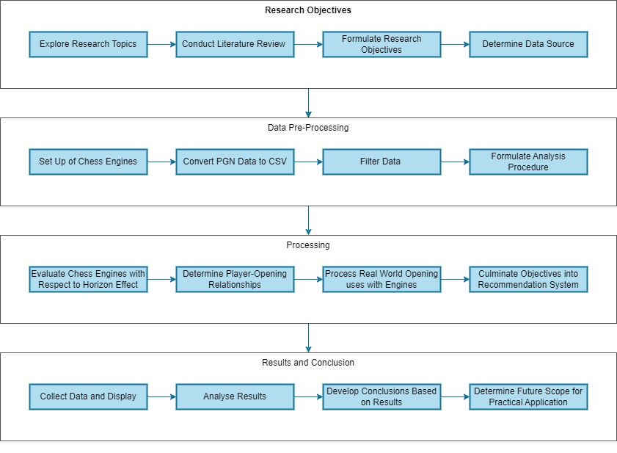

# Appendix B: Data Permissions and software Licenses

# Lichess

The Lichess database is released under the Creative Commons CC0 License.

Details are available at:  
<https://database.lichess.org/>  
<https://www.tldrlegal.com/license/creative-commons-cc0-1-0-universal>

# Stockfish

Stockfish is distributed under the GNU General Public License version 3 (GPL v3)

Details are available at:  
<https://github.com/official-stockfish/Stockfish/blob/master/Copying.txt>

# Leela Chess Zero

Leela Chess Zero is distributed under the GNU General Public License version 3 (GPL v3)

Details are available at:  
<https://github.com/LeelaChessZero/lc0#license>

# Python

Python is developed under an OSI-approved open source license, making it freely usable and distributable.

Details are available at:  
<https://www.python.org/about/>  
<https://opensource.org/license/python-2-0/>